Web Full Stack

Softwares required

1. Java 8 - JDK & JRE
2. Eclipse IDE for Enterprise Developer - (2020-06) 0R (2020-09)

Once you install java software you need to set the environment variable in your personal machine. So that javac will be recognized.

Java

Java is a platform independent and Object oriented programming language.

Platform Independence: It can run on any platforms without altering.

Object Oriented: An application will have realworld entities which are called as object, which will be created to make application work, one object calls another object behaviour to complete their task.

ex: Customer object can have deposit(), that can call Account object credit() functionality.

Two main building blocks of Java

1. Classes - Blue print of an object (template for an object)
2. Objects - Instances of a class

A class can be created inside a Java source file with an extension .java, a class can have variables, methods & constructors, all these should follow some standard naming conventions.

Filenames, classnames & constructors: Should begin with Capital letters & Follow camel case

variable names & method names: Should begin with Small letters & Follow camel case.

Commands we use to compile & run java program

1. javac: to compile
   1. ex: javac Filename.java
2. java: to run
   1. ex: java ClassnameHavingMainMethods

Note: In java main method signature is ‘public static void main(String[] args)’

public, static & void are keywords the java can recognize

main is a method name

String is predefined class

HelloWorld.java

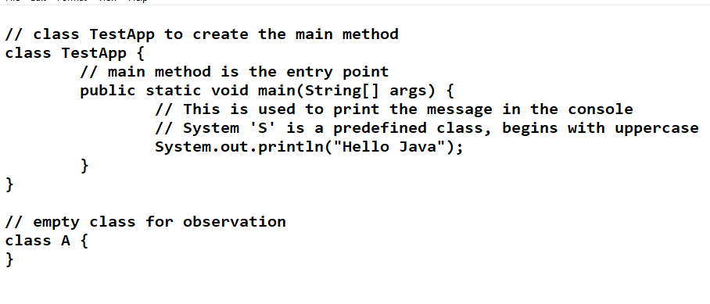

Output:

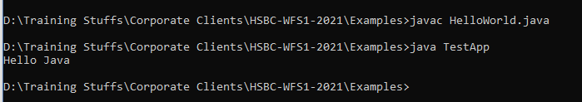

Using Eclipse IDE

Eclipse is a tool to develop applications quickly, it gives lot of suggestions to the programmers so that they can quickly write programs.

Eclipse will have all the projects in the workspace, you have different perspectives like

* Java (Java applications)
* JavaEE - Default (servlets & JSP)

Packages: They are used to categorize your classes, they are like folders

Their names would be like a domain name ex: com.hsbc, com.google, com.oracle

HelloWorld.java

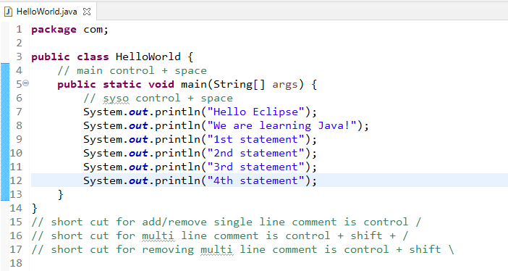

Java Fundamentals

1. Operators
2. Keywords
3. Datatypes
4. Variables
5. Conditional Statements
6. Loops
7. Arrays
8. Methods
9. Classes & Objects

Operators:

+, -, *, /, =, ==, <=, >=, !=, &&, ||, ++, --, +=, -=, /=, *=

Keywords: These are reserved words in java

public, package, static, void, int, long, float, double, char, byte, short, if, for, while, do, switch, case, default, break, return, continue, final, interface, class, enum, try, catch, finally, extends, implements, super, this, throw, throws, synchronized, abstract, volatile, native,

Datatypes

1. Primitive types: keywords in java and fixed in size
   1. byte, short, int, long - Integer types: whole numbers
   2. float & double - Floating types: real numbers
   3. char - Character types: single char
   4. boolean - Boolean true or false
2. Non-Primitive types: classes, interfaces, arrays, enum - not fixed in size
   1. String, Employee, Customer, Student, StringBuilder
   2. int[], float[], double[]

Variables: These can store data of specific type

Syntax: type variable_name = value;

ex: int employeeId = 100;

ex: double salary = 25000;

TestFundamentals1.java

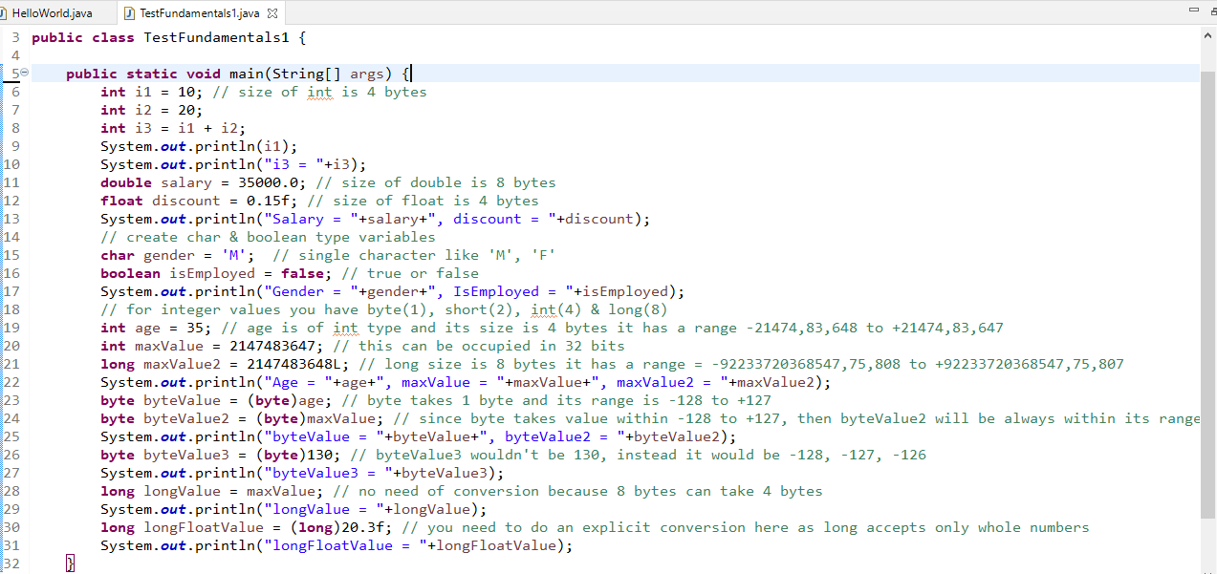

Output:

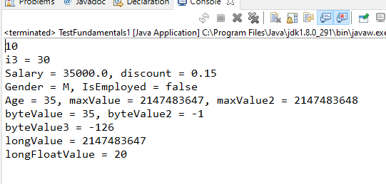

Passing data to a method having parameter

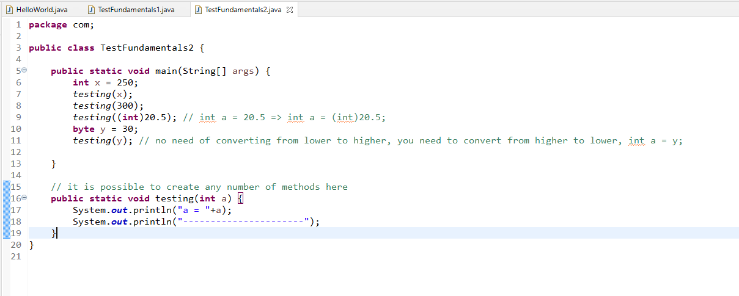

Conditional Statements

1. if
2. if-else
3. if else-if else-if….
4. if else-if else-if…. else
5. switch

Taking input from keyboard

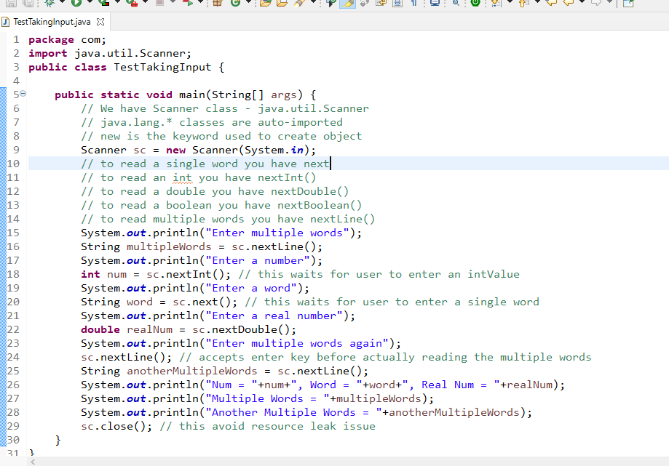

Output:

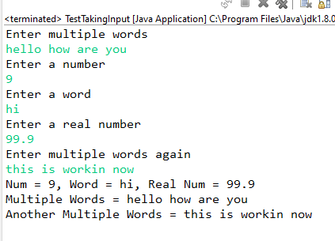

How to create objects

Customer.java

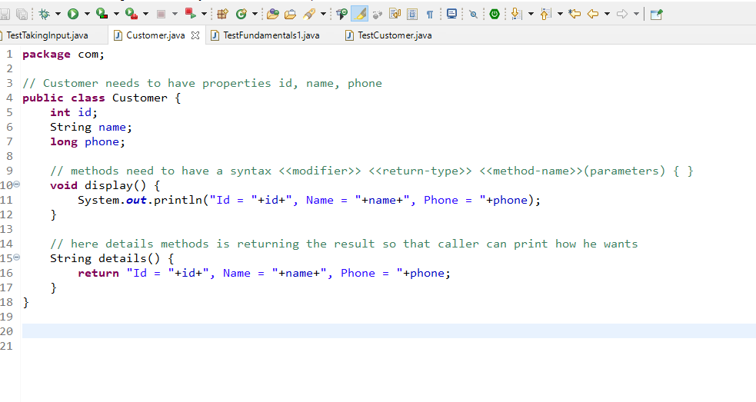

TestCustomer.java

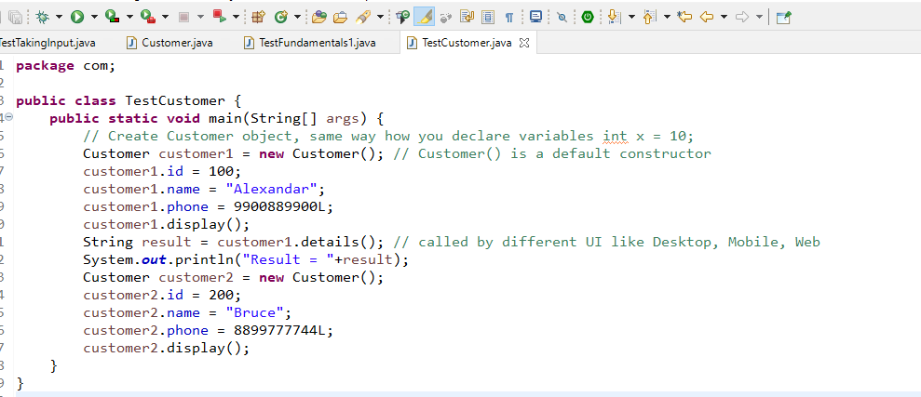

Customer.java

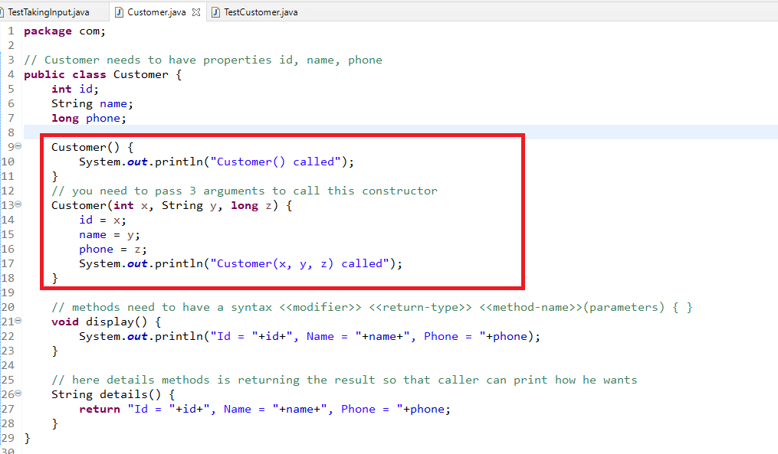

TestCustomer.java

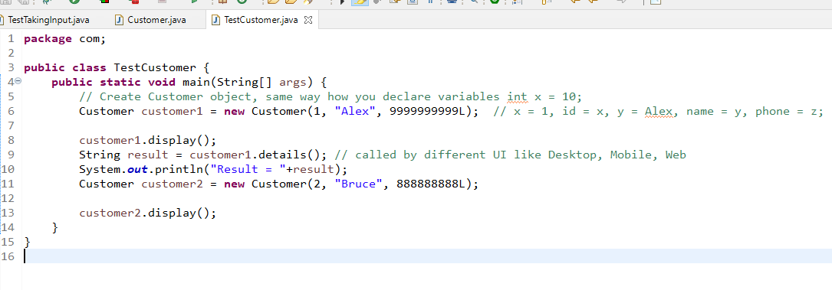

Constructors take care of initializing the objects property.

Some important points on constructor

1. Compiler creates constructor if there’s not constructor inside the class
2. If User has created the constructor then compiler retains that constructor and doesn’t create any constructor, user may create default or parameterized constructor

OOPS features

1. Encapsulation
2. Inheritance
3. Polymorphism
4. Abstraction

Encapsulation: Hiding the data by making variables private and the only way you can access them is through public methods like setters or getters

Student.java

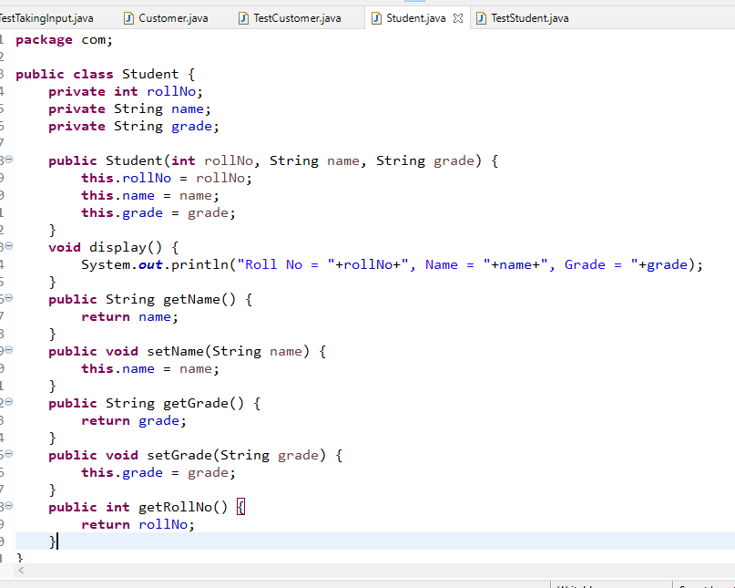

TestStudent.java

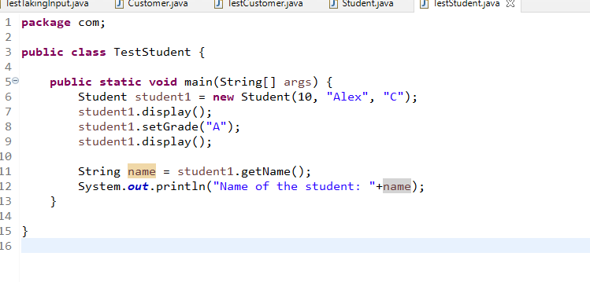

Fundamentals of Java

* Operators
* Datatypes
* Variables
* Methods
* Classes & Object

Day 2:

Conditional Statements

Loops

Arrays

Object Arrays

Constructors

String & String methods

Inheritance

Gmail -> User(username, phone, password, gender,….)

Gmail -> username -> getUsername(), setPhone(long), getPhone(), setPassword(String), getPassword(), getGender(), setGender(String)

Employee -> id, name, age, salary, desig, setAge(int) { age >= 18}

Conditional Statements

1. if
2. if - else
3. if - else if else if….
4. if - else if else if….else
5. swtich

TestConditions

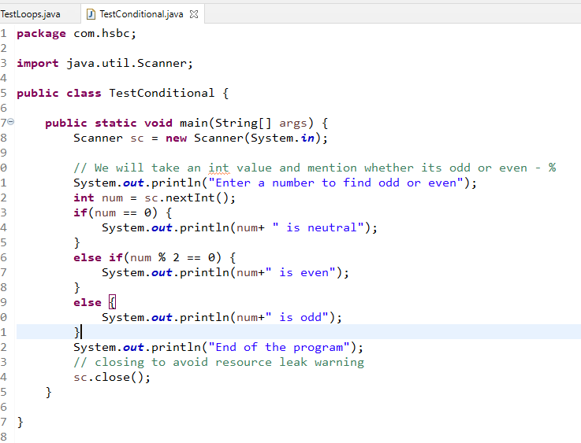

TestConditional2

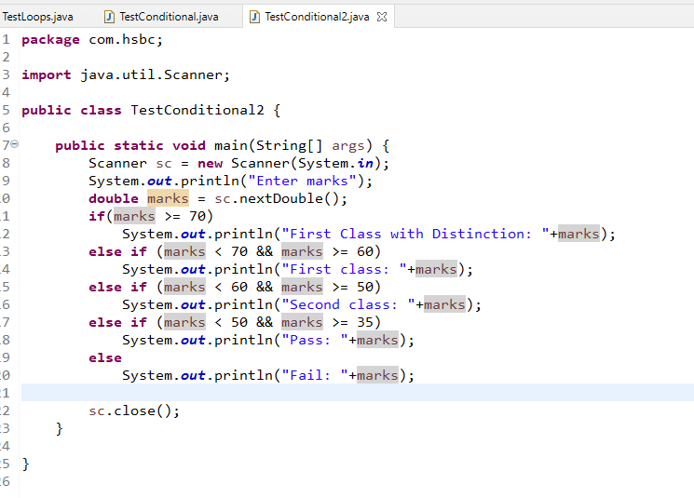

switch:

switch also works like if else if .. else, but it only uses integer, string, character & enum

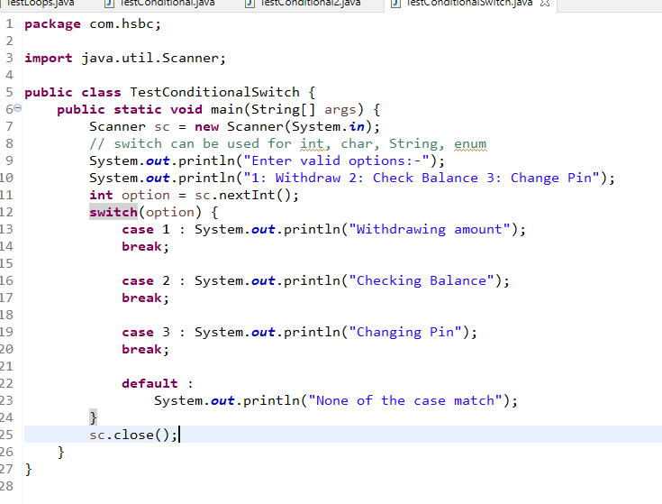

Loops:

1. for : when you know how many times you want to iterate
2. while: when you want to iterate until the condition is true
3. do-while: same like while but it is an exit control loop, at least once the statement inside the do-while will be executed

TestLoops.java

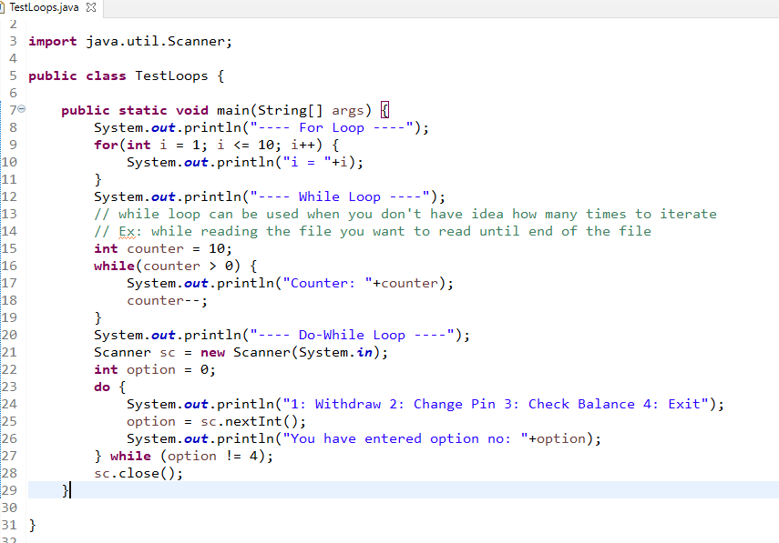

Arrays:

It is a container which can store more than one elements of same type, you can create simple arrays to complex type of arrays

1. Simple arrays:
   1. int[] items = {3, 1, 2, 6, 5};
   2. String[] values = {“Alex”, “Raj”, “Vijay”};
   3. int[] items = new int[5];
      1. items[0] = 1, items[1] = 5, items[2] = 10
2. Complex arrays: Array of complex types i.e., complex objects
   1. Customer[] customers = new Customer[5]; creates memory to store 5 customer objects
      1. customers[0] = new Customer(1, “Alex”, 50);
      2. customer[1] = new Customer(2, “Bruce”, 45);
      3. customer[4] = new Customer(5, “David”, 22);

You can create different dimensional arrays like one dimensional array & two dimensional array.

1. One dimensional array: int[] arr = new int[5]; // memory is allocated for 5 int values
2. Two dimensional array: int[][] arr = new int[5][4]; // memory is allocated for 20 int value
   1. int[0][0] = 15; // 0th row & 0th column
   2. int[1][1] = 10; // 1st row & 1st column

TestOneDArray.java

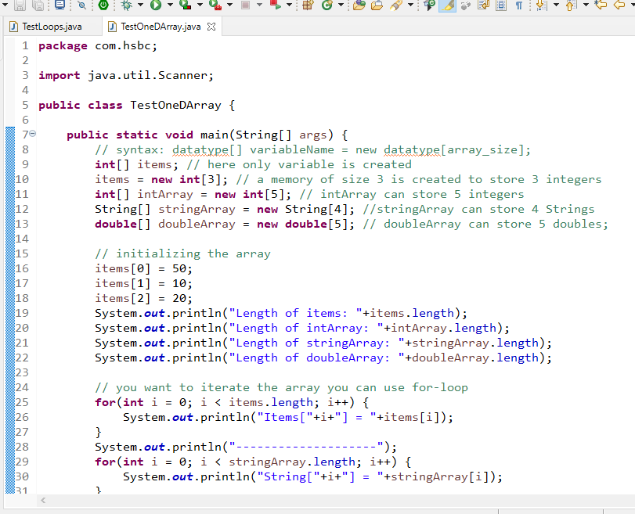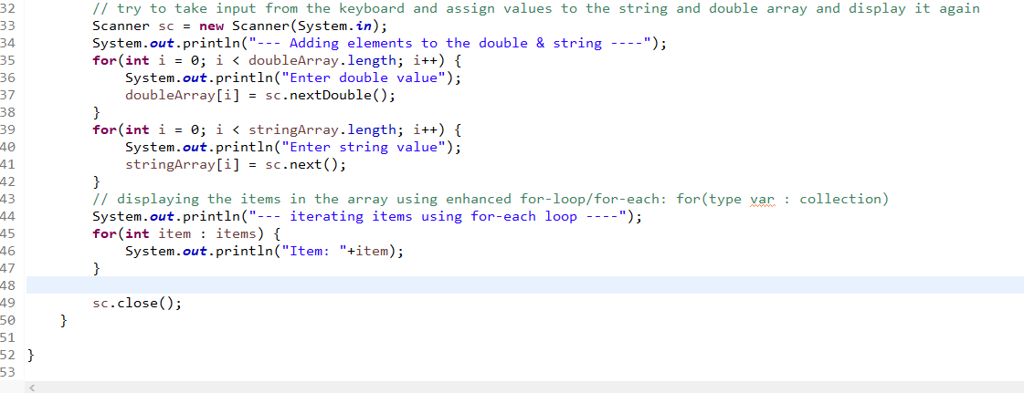

Creating complex type array

Customer[] customers = new Customer[5];

Note: each index will have null by default

customers is an array of size 5, it means in each index you can store customer object and maximum you can store 5 customer objects

Customer.java

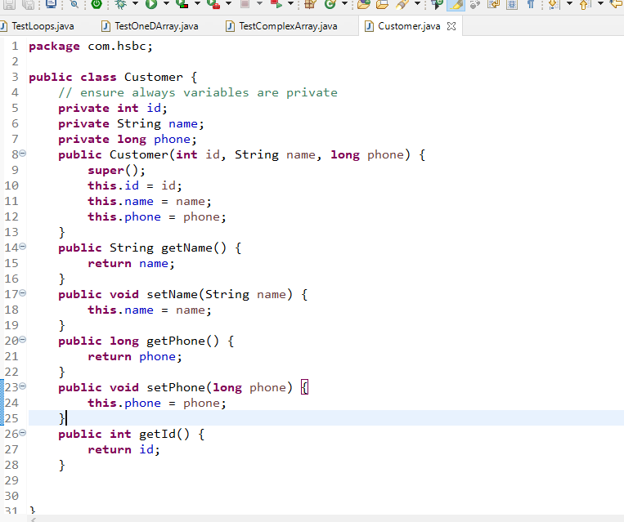

TestCustomerArray.java

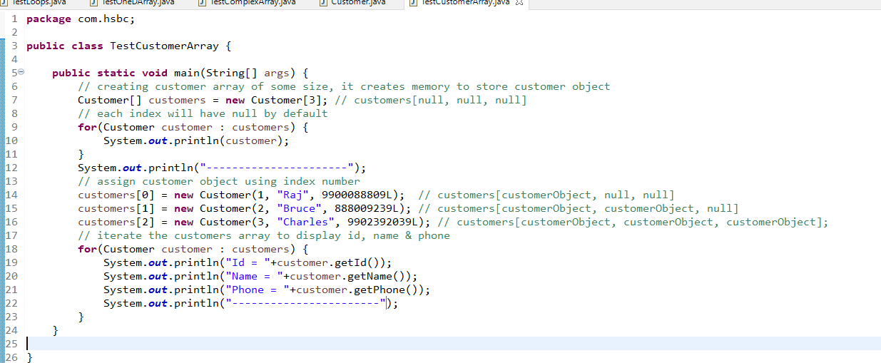

Output:

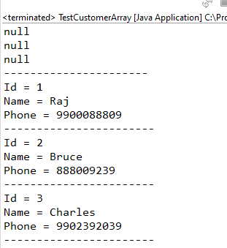

Taking value of customers dynamically

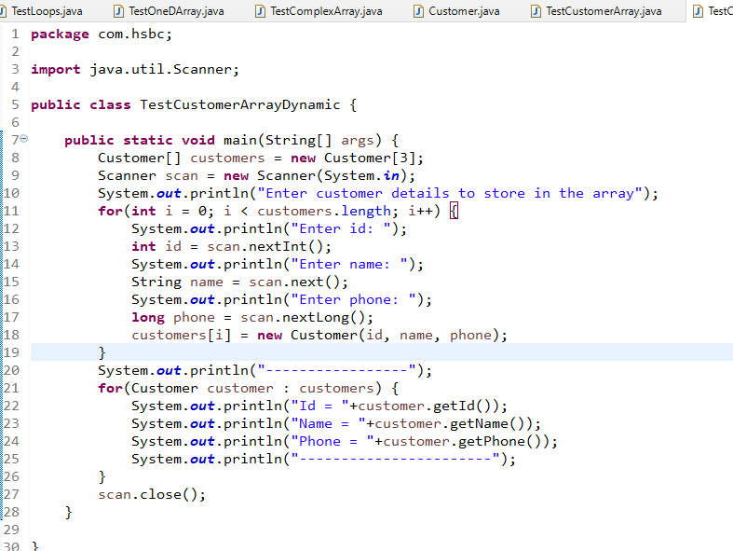

Two-dimensional array

1. type[][] variable_name = new type[row][col];
2. type[][] variable_name = {{v1, v2, v3, v4}, {v5, v6, v7},…};

To iterate two-dimensional array you need to two loops i.e., one nested within another

You can use both traditional for loop if in case you want to do any changes if in case you are only retrieving you can use for-each

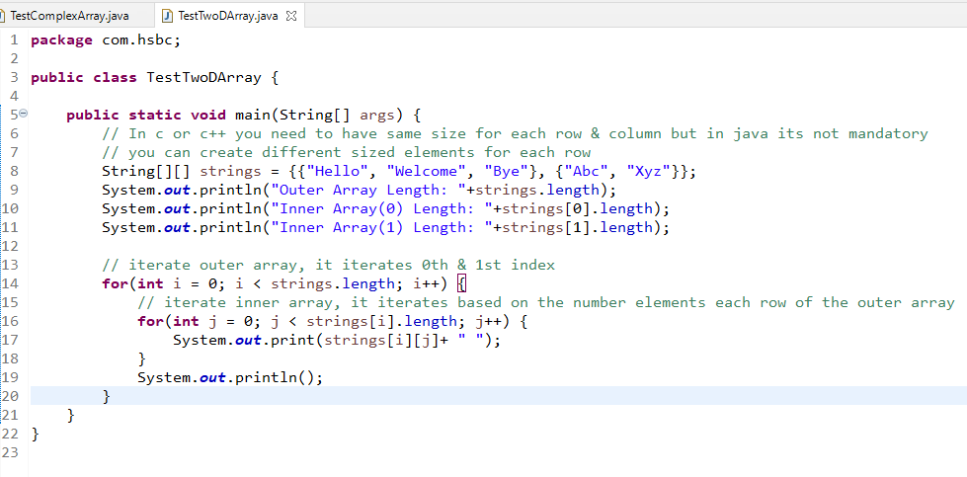

Output:

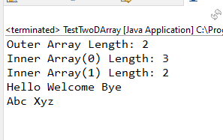

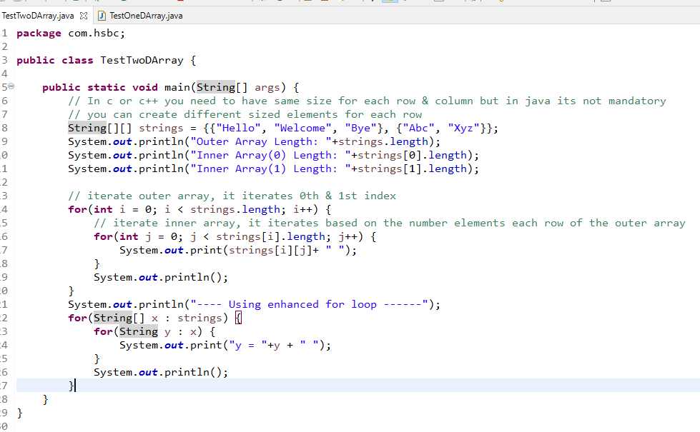

Output:

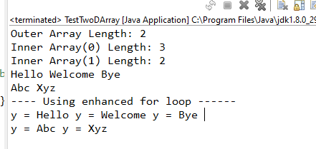

We have lot of predefined classes in java, we need instance of those classes to access the methods, some methods you can directly if they are static methods.

class Abc {   
 void test1() { …. }

static void test2() { …. }   
}

// test2() can be accessed using Abc.test2();

// test1() can be accessed by using reference of instance

Abc a = new Abc();

a.test1();

String class in an inbuilt class which has methods that are very useful, some of the methods are:

equals()

length()

equalsIgnoreCase()

toUpperCase()

toLowerCase()

charAt()

indexOf()

lastIndexOf()

split()

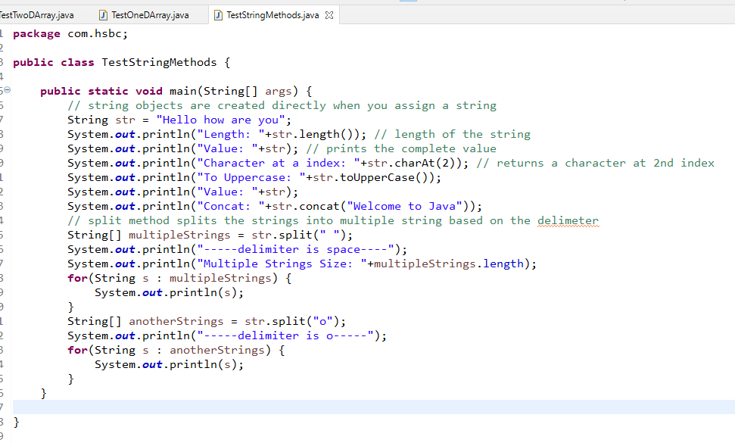

Output:

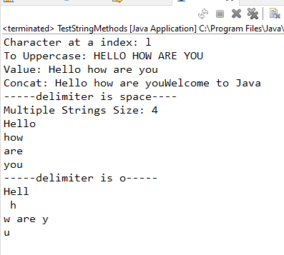

TestMethodOverloading

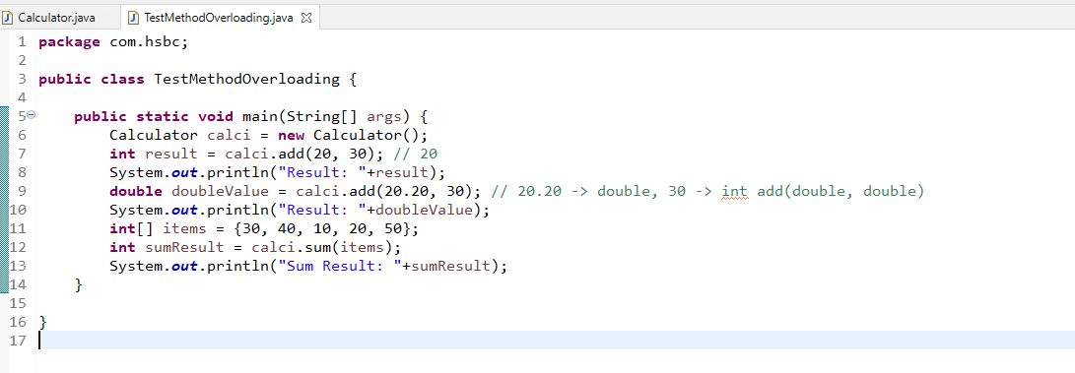

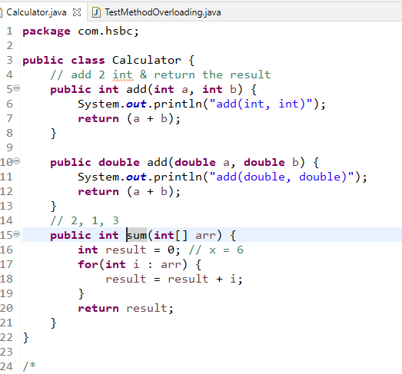

Output:

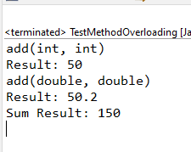

this keyword

It refers to current object, it differentiates between the instance variable & parameter variable when the variable is sharing same name.

Another use of this is it is used call current class constructor, to reuse the initialization statement.

Employee.java

**package** com.hsbc;

**public** **class** Employee {

**private** **int** id;

**private** String name;

**private** String gender;

**private** **double** salary;

**private** String email;

**private** **long** phone;

// creating the constructor when id & name is mandatory

**public** Employee(**int** id, String name) {

**this**.id = id;

**this**.name = name;

System.***out***.println("Employee(id, name)");

}

// creating the constructor when certain fields are mandatory

/*

* this() -> Employee()

* this(int, String) -> Employee(int, String)

* this(int, String, double) -> Employee(int, String, double)

* this(int, String, String, double, String, long) -> Employee(int, String, String, double, String, long)

*

*/

**public** Employee(**int** id, String name, **double** salary) {

**this**(id, name); // Employee(int, String)

**this**.salary = salary;

System.***out***.println("Employee(id, name, salary)");

}

// you can create constructor to initialize any number of properties

**public** Employee(**int** id, String name, String gender, **double** salary, String email, **long** phone) {

**this**(id, name, salary); // Employee(int, String, double);

**this**.gender = gender;

**this**.email = email;

**this**.phone = phone;

System.***out***.println("Employee(id, name, gender, salary, email, phone)");

}

**public** **int** getId() {

**return** id;

}

**public** **void** setId(**int** id) {

**this**.id = id;

}

**public** String getName() {

**return** name;

}

**public** **void** setName(String name) {

**this**.name = name;

}

**public** String getGender() {

**return** gender;

}

**public** **void** setGender(String gender) {

**this**.gender = gender;

}

**public** String getEmail() {

**return** email;

}

**public** **void** setEmail(String email) {

**this**.email = email;

}

**public** **long** getPhone() {

**return** phone;

}

**public** **void** setPhone(**long** phone) {

**this**.phone = phone;

}

**public** **double** getSalary() {

**return** salary;

}

**public** **void** setSalary(**double** salary) {

**this**.salary = salary;

}

}

TestEmployeeWithThis.java

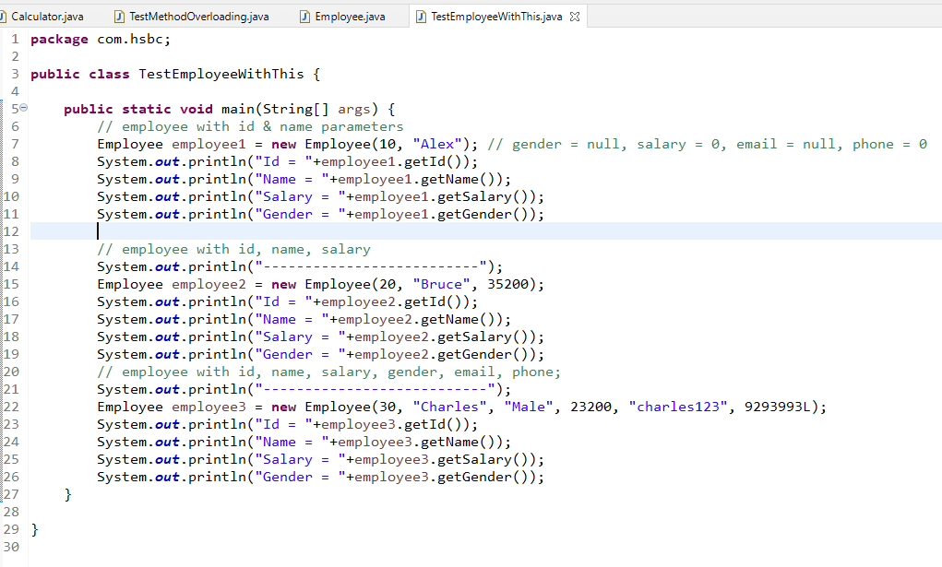

Output:

Employee(id, name)

Id = 10

Name = Alex

Salary = 0.0

Gender = null

--------------------------

Employee(id, name)

Employee(id, name, salary)

Id = 20

Name = Bruce

Salary = 35200.0

Gender = null

---------------------------

Employee(id, name)

Employee(id, name, salary)

Employee(id, name, gender, salary, email, phone)

Id = 30

Name = Charles

Salary = 23200.0

Gender = Male

Note: call to the constructor using this() must always be in the very first line of the constructor

Static & Non-Static (Instance)

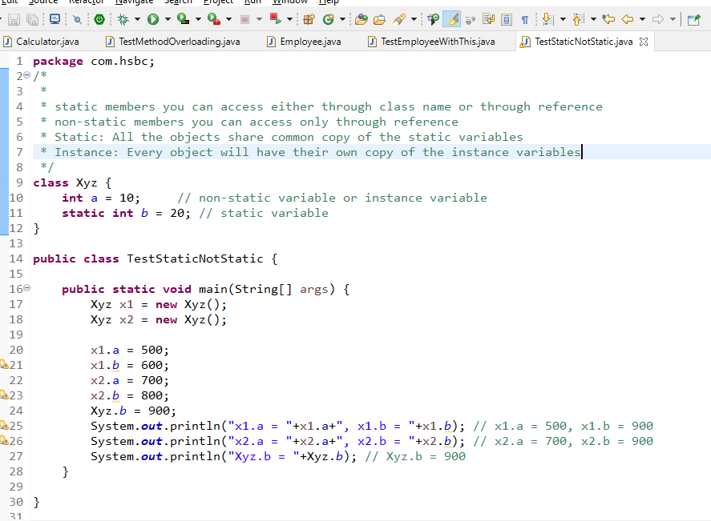

Output:

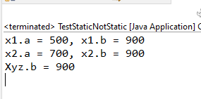

Inheritance:

A process of acquiring common properties & behaviours of an object from another object, you can create common properties & behaviours in the super class & inherit to the subclass.

Java allows you to achieve inheritance using extends keyword.

class A { }

class B extends A { }

Note: private members & constructors wouldn’t be inherited

Person.java

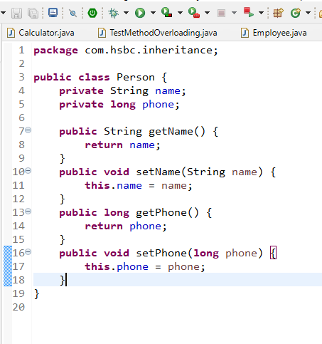

Employee.java

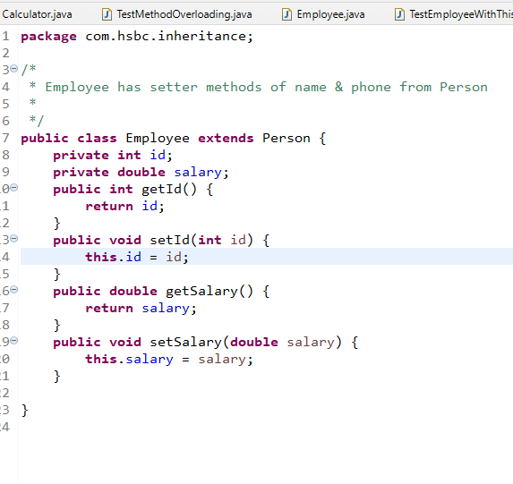

TestInheritance.java

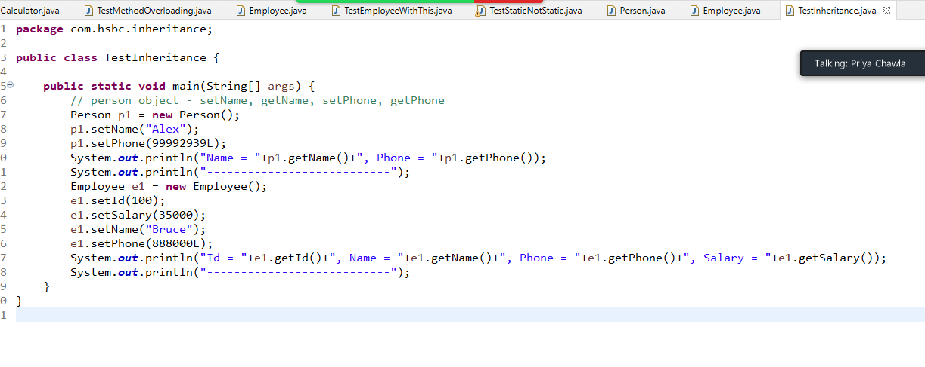

Output:

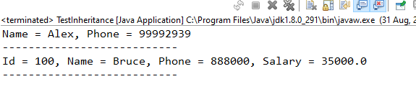

Day 3 - 01-09-2021

Person.java

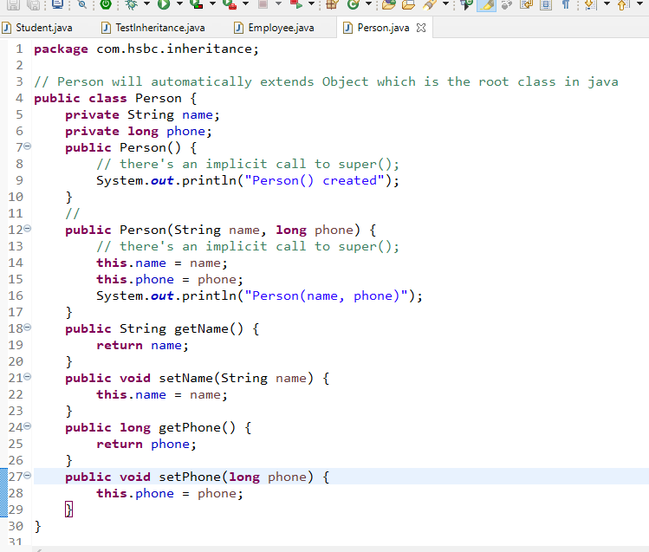

Employee.java

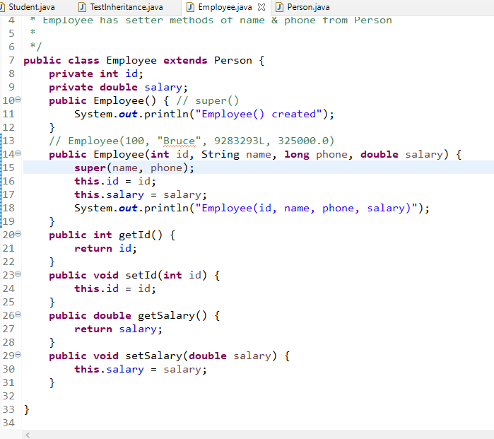

Student.java

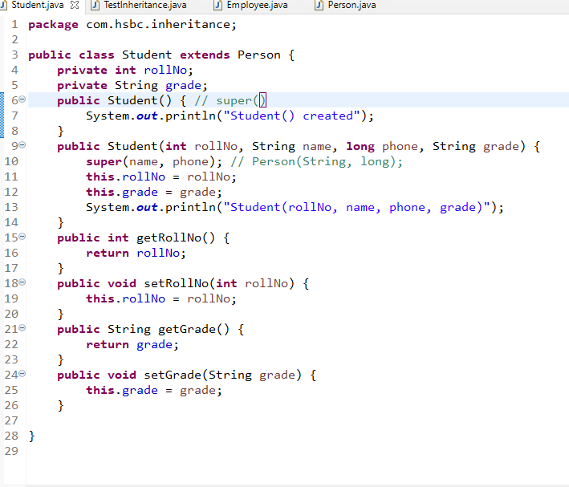

TestInheritance.java

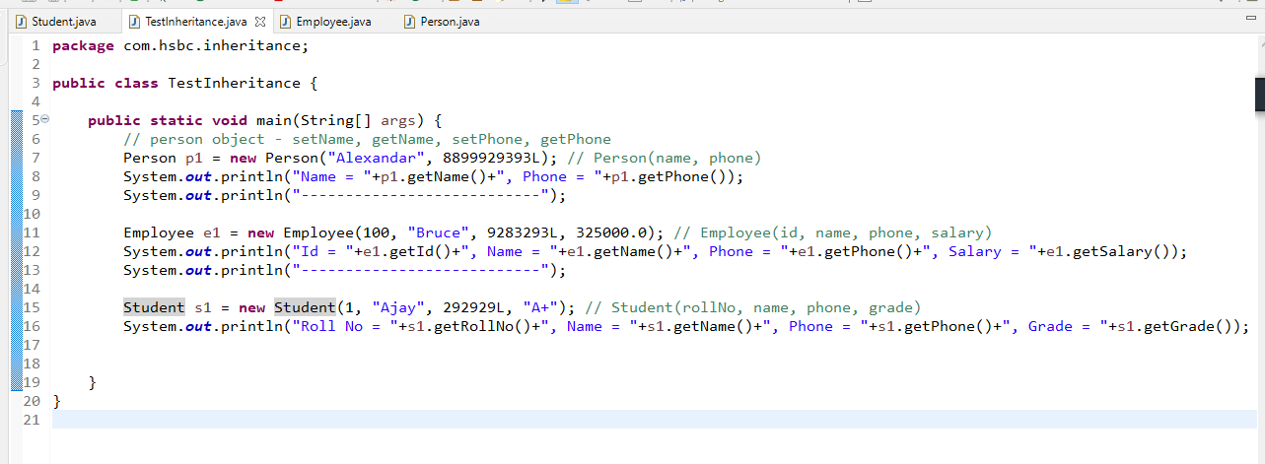

Output:

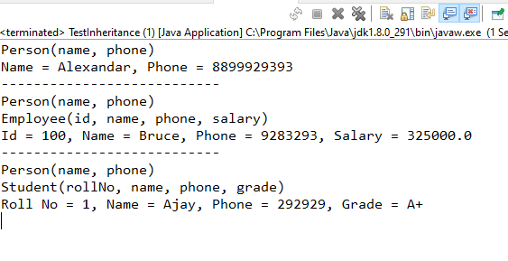

Note: If a class doesn’t have any super class then it automatically extends Object class which is the root class in java

Some of the important methods of Object class are:

1. toString(): called when you print the object, it returns memory address by default in hexadecimal format
2. equals(): used to compare two objects
3. hashCode(): returns a unique id of the object which is called as hashCode of the object.

Polymorphism

An object with many forms i.e., multiple methods of the same name but performs different action, (or) A method which performs different action based on the object

ex: power button has different behaviours like on/off both

There are two types of polymorphism

1. Compile time polymorphism: method overloading: You can predict which method gets called at compilation
2. Runtime polymorphism: method overriding: You can’t predict which method gets called at compilation time, because the method execution depends on the object that is calling

Method Overloading: Same method name but different signature(type of parameters, number of parameters) in the same class

Method Overriding: Same method name & the signature written in subclass with different logics particular to the subclass.

Simple polymorphism program

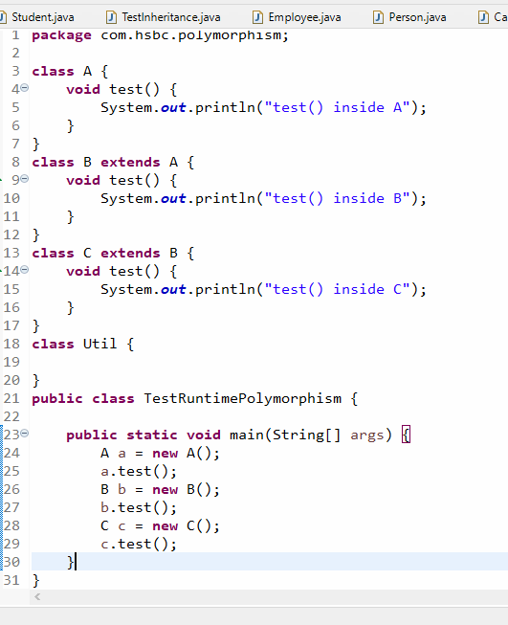

Output:

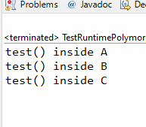

Note: You can assign multiple instances to the same reference, however the reference type should be superclass type

A a = new A(); B b = new B(); C c = new C();

A obj;

obj = a; // obj is of A type and a is of A type

obj = b; // obj is of A type and b is of B type

obj = c; // obj is of A type and c is of C type

This is possible because higher types can always take lower types

ex:

long x ;

int y = 30; short z = 50; byte t = 60;

x = y; // x is long type and y is int type

x = z; // x is long type and z is short type

x = t; // x is long type and t is byte type

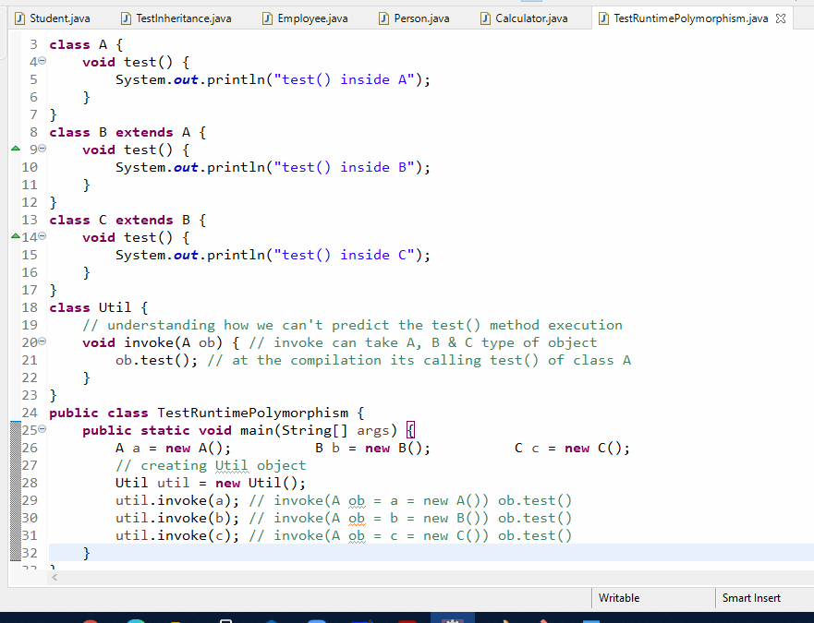

Output:

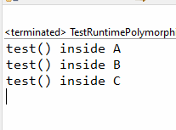

When you have a super class reference only overridden methods can be called as they are defined from super class, but you can’t access subclass members with super class reference, inorder to access subclass members you need to do a typecasting i.e., explicit downcasting.

A a = new B();

‘a’ can access only members of class A, if a wants to access members of class B you need to explicit downcast

B b = (B) a; // but you need to be cautious, because it may generate class cast exception, to avoid that you can use instanceof keyword

TestDowncasting.java

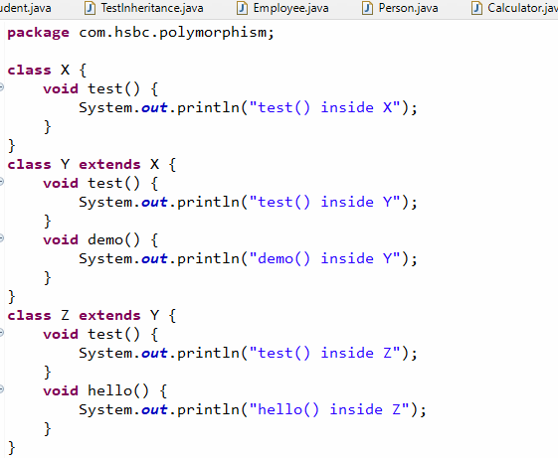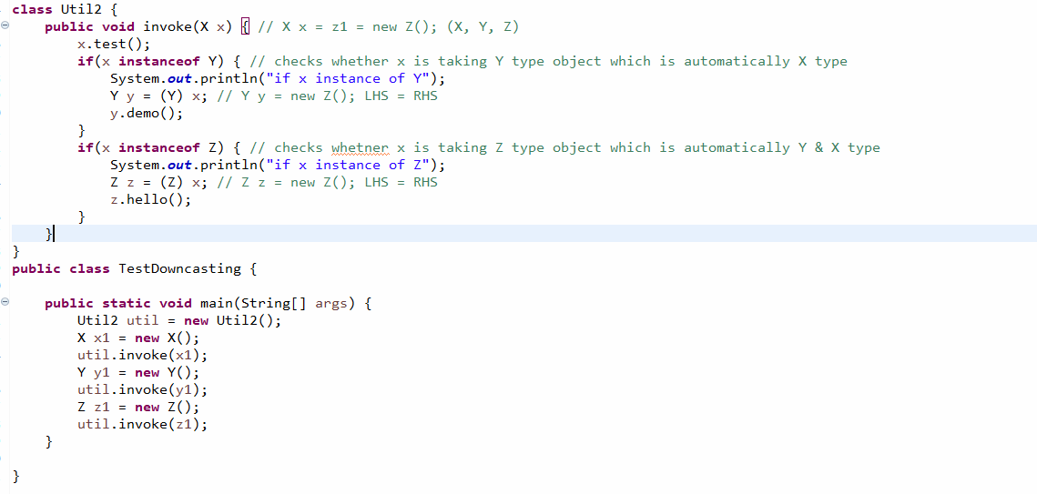

Output:

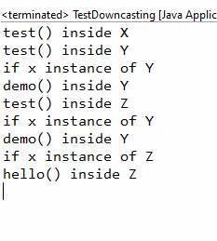

Abstraction: It hides the complexity from the user & shows only the necessary details so that user can work on the application or object easily.

Here in OOPS the complexities are implementations of the methods and showing only the necessary details means showing only the methods signatures.

It makes developer to think about what the method does instead of how the method does

Ex:

Developer1: store(User user) { …. connecting to DB … } 1 or -1

Developer2: register() -> UI -> reads user data can calls store(user); 1 or -1

How to achieve abstraction

It can be achieved in two ways

1. interface: complete abstract: all the methods are abstract
2. abstract class: partial abstract: some methods can be abstract & some are not

abstract means incomplete methods i.e., methods without body i.e., method declarations.

Interface:

It is like a class but will have only abstract methods & constants, it will not have constructors or complete methods

How to create interface

public interface interface_name {   
 return_type method_name(arguments);  
 return_type methods_name(arguments);  
}

Ex:

interface Vehicle {  
 void mileage();  
 void wheels();  
}

abstract class Car implements Vehicle { } // implements wheels()

class Innova extends Car { } // implements milage()

class Swift extends Car { } // implements mileage()

abstract class Bike implements Vehicle {} // wheels()

class KTM extends Bike { } // implements mileage()

class Pulsar extends Bike { } // implements mileage()

Now all the above classes needs to mandatorily implement mileage & wheels methods.

Rule:

If you have an interface you can only create abstract methods, a class needs to mandatorily override all the abstract methods else class should be made abstract.

Vehicle.java

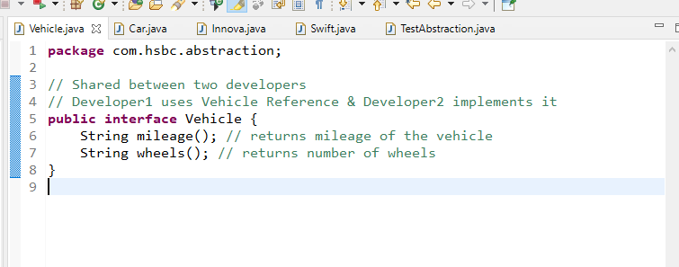

Car.java

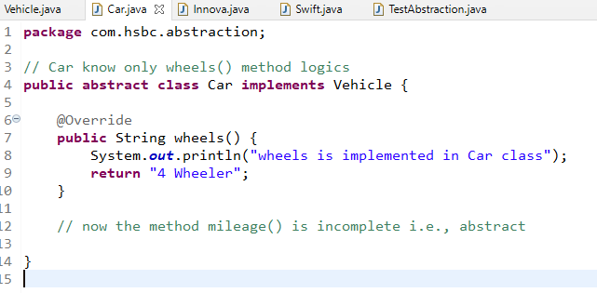

Innova.java

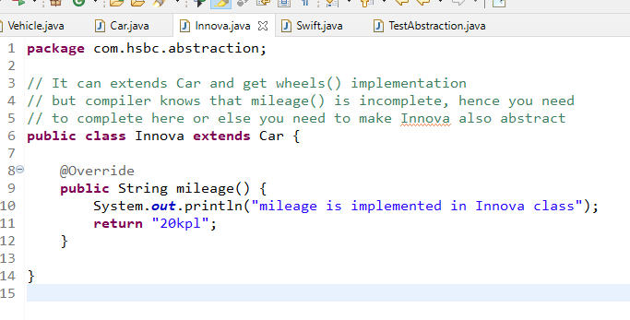

Swift.java

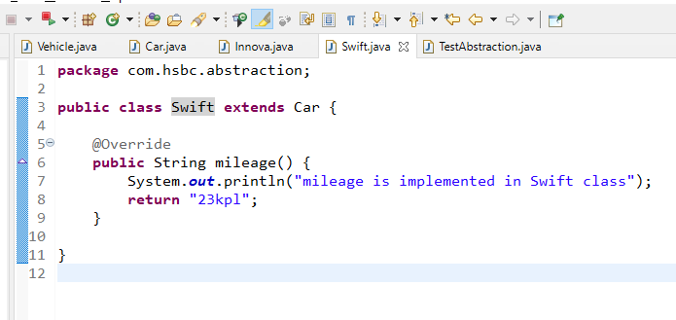

TestAbstraction.java

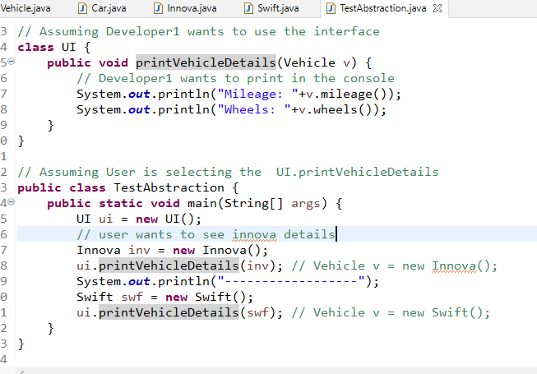

Output

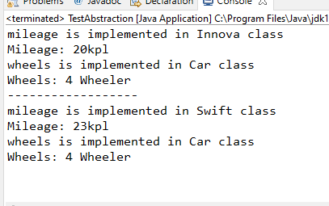

Note: Inside interface all the members are by default public, even if you don’t use public, and also all the methods are abstract by default, all the variables are constants by default

Some of the important points on interface

1. The main purpose of using interface is to achieve the complete abstraction
2. interface can have only abstract methods
3. interface members are public by default
4. methods are public & abstract by default
5. variables are public, final & static
6. interface cannot have constructors
7. interface cannot be instantiated
8. class can implement more than one interface

if I1, I2, I3 are 3 interfaces then class C1 implements I1, I2, I3 {}

1. interface can extend more than one interface like multiple inheritance

If I1, I2, I3 are interfaces then interface I4 extends I1, I2, I3 { } is ok

Access Specifiers in Java

They are used to represent the visibility of classes, methods & variables, totally there are 4 access specifiers

1. private
2. no keyword for it (default access specifier)
3. protected
4. public

|  |  |  |  |
| --- | --- | --- | --- |
| Private | Default | Protected | Public |
| Visibility is only within the class | Visible only within the package and not visible outside the package | Visible within the package & outside the package only to the subclass | Visible to everyone |

package com;  
public class A { }   
class B { }

package org;  
import com.A; // valid  
import com.B; // compilation error

Passenger -> bookTickets();

cancelTickets();

Admin -> bookTickets();

cancelTickets();

modifyPassenger();

interface PassengerInterface { bookTickets(); cancelTickets() ; }

interface AdminInterface extends PassengerInterface { modifyPassenger(); }

class TickeService implements PassengerInterface, AdminInterface { } (OR)

class TickeService implements AdminInterface { }

abstract class Passenger { bookTickets(); cancelTickets(); }

abstract class Admin extends Passenger { modifyPassenger(); }

class TicketService extends Admin { 3 methods you will implement }

Developer -> UI -> Passenger p = new TicketService(); p.bookTickets(); p.cancelTickets();

Developer -> UI -> Admin a = new TicketService();

a.bookTickets();

a.cancelTickets();

a.modifyPassenger();

Developer -> UI -> Passenger -> PassengerInterface pi = new TicketService();

pi.bookTickets();

pi.cancelTickets();

pi.modifyPassenger(); // not possible at all

Developer -> UI -> Admin -> AdminInterface ai = new TicketService();

ai.bookTickets();

ai.cancelTickets();

ai.modifyPassenger(); //possible

When you develop any application you need to follow an architecture called as layered architecture i.e., MVC

Factory Pattern:

It takes care of creating the object & returning to the client code, by hiding which class is instantiated.

interface DAO {   
 void store();  
 void fetch();  
}

class DAOMySQL implements DAO { all methods must be implemented }

// without factory pattern Service Layer

1st approach: DAOMySQL dao = new DAOMySQL();

2nd approach: DAO dao = new DAOMySQL();

3rd appraoach: Using factory pattern

class DAOFactory {   
 public DAO getInstance() {   
 return new DAOMySQL();  
 }  
}

3rd approach:

DAOFactory factory = new DAOFactory();  
DAO dao = factory.getInstance(); // returns DAOMySQL

Service Layer can call methods of DAO interface like

dao.store();

dao.fetch();

Creating the application using layered architecture

1. DAO layer: It will have methods that interact with the database, it should have methods as per the interface rules
2. Service layer: It will have methods that calls DAO layer methods, it should also have methods a per the interface rules
3. Controller layer: it will have methods that calls Service layer methods
4. View layer: it will have the User Interface
5. Factory Pattern: Takes care of creating the instances of DAO & Service and returning to the Service & Controller respectively. i.e., DAO instance returned to the Service & Service instance is returned to the Controller

Note: Certain features are missing here

1. We are missing database here hence we use arrays as the temporary
2. We are also missing the view layer like Web, Mobile, Desktop and also controller will decide the view so we can’t have controller now, hence we use console itself as a view layer & controller layer

View layer role: Take input from the user & show the output to the user, now in console you can use Scanner to take input & System.out.println() for output.

TestDAO.java

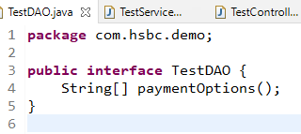

TestDAOImp1.java

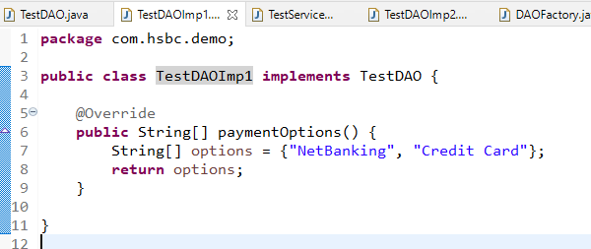

TestDAOImp2.java

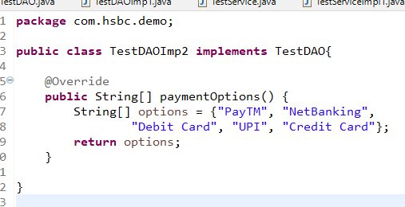

TestService.java

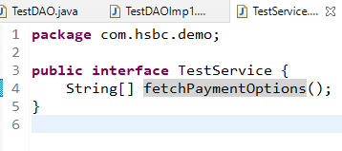

TestServiceImpl1.java

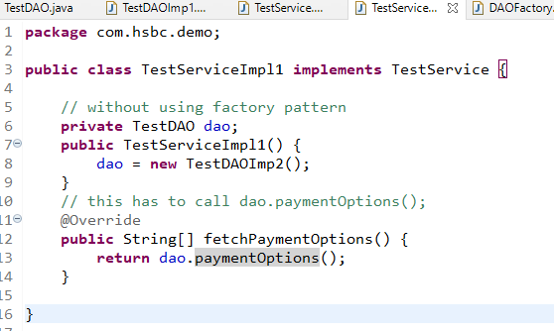

TestViewController.java

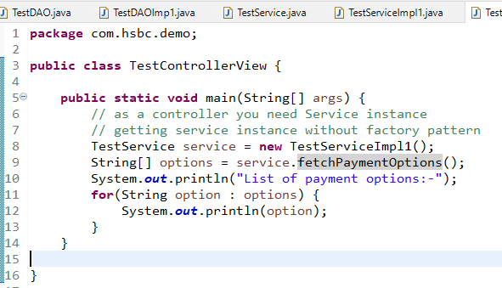

Output:

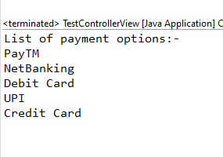

Here we are getting the output from the TestDAOImp2, but if we change the DAO we are changing Service as well, to remove this dependency we go with factory pattern which takes care creating object & returning the object

DAOFactory.java

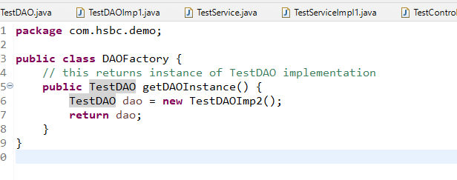

Here the factory is creating TestDAOImp1 instance and client which is Service can use this factory and get the DAO instance that way you are completely abstracting the object creation at the client side.

TestServiceImp1.java

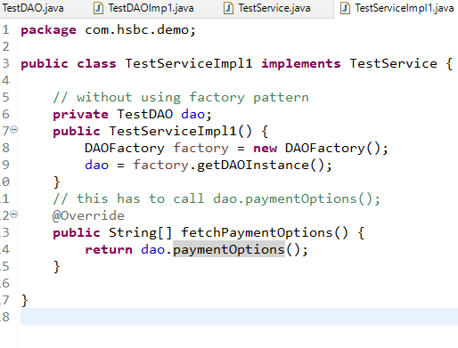

But you need to change in the Controller also as controller is creating instance using new operator

ServiceFactory.java

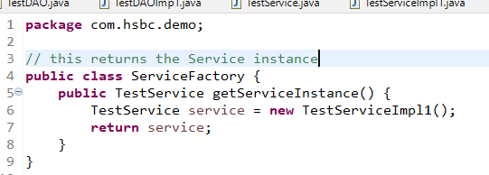

TestControllerView.java

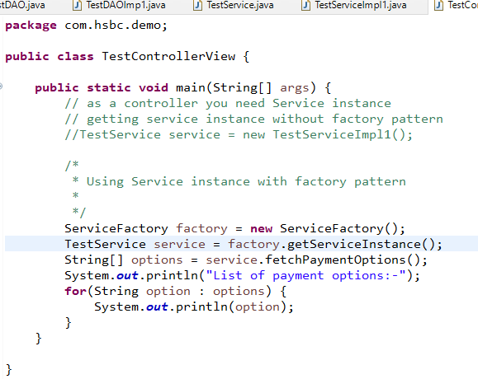

The above one has 2 factory classes, but what you can do is you can create one ObjectFactory class that returns different types of instances like Service, DAO and also these factory methods can have some parameter and return the object of different implementation by checking the condition using the parameter

ex:

public TestDAO getDAOInstance() { … } // existing one  
public TestService getServiceInstance() {..} // existing one

// you need to implement

public TestDAO getDAOInstance(int option) {   
 // if option is 1 return TestDAOImp1  
 // if option is 2 return TestDAOImp2  
}

public TestService getServiceInstance(TestDAO dao) {  
 // return new TestServiceImp1(dao)  
}

// client code shouldn’t be modified, without modifying service & dao it should work on TestDAO1 & TestDAO2 by passing option from the main method

i.e.,

if you pass 1, then it gives TestDAOImp1

TestDAO dao = factory.getDAOInstance(“1”);

TestService service = factory.getServiceInstance(dao);

if you pass 2, then it gives TestDAOImp2

TestDAO dao = factory.getDAOInstance(“2”);

TestService service = factory.getServiceInstance(dao);

Exception Handling

Exception: Runtime errors, it needs to be handled else program will be abnormally terminated, there are 5 keywords in Exception Handling

1. try
2. catch
3. finally
4. throw
5. throws

try, catch & finally are block statements that can have logics, whereas throw & throws are not blocked statements.

1. try block: You can write those logics that might generate exception, but if the exception is generated java will look for the handler i.e., catch block
2. catch block: It can handle the exception generated from try block, after the try you can have any number of catch blocks
3. finally block: It is executed for all the cases like whether or not exception handled or when the exception is not occurred also, it is definitely executed regardless of any conditions happens while using try-catch

Note: finally block is optional, but it needs to be written at the end of either just try or try-catch blocks

ex: try-finally (or) try-catch-catch-finally

1. throw keyword: it is used to manually generate exception
2. throws keyword: it is used to propagate the exception to the caller instead of handling in the method

There is an hierarchy in the exception

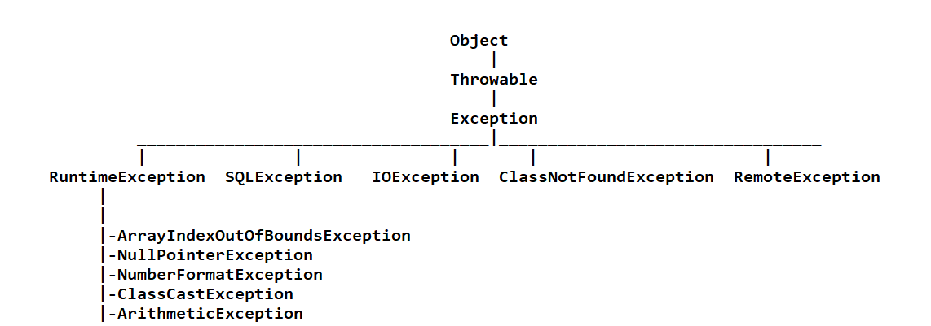

In this hierarchy there are two types of exceptions

1. Checked Exception: Need to be handled - All the subclasses of Exception are checked, except RuntimeException & their subclasses
2. Unchecked Exception: Optional to handle - RuntimeException & their subclasses are unchecked exception, that is compiler ignores these exceptions

TestExceptions1.java

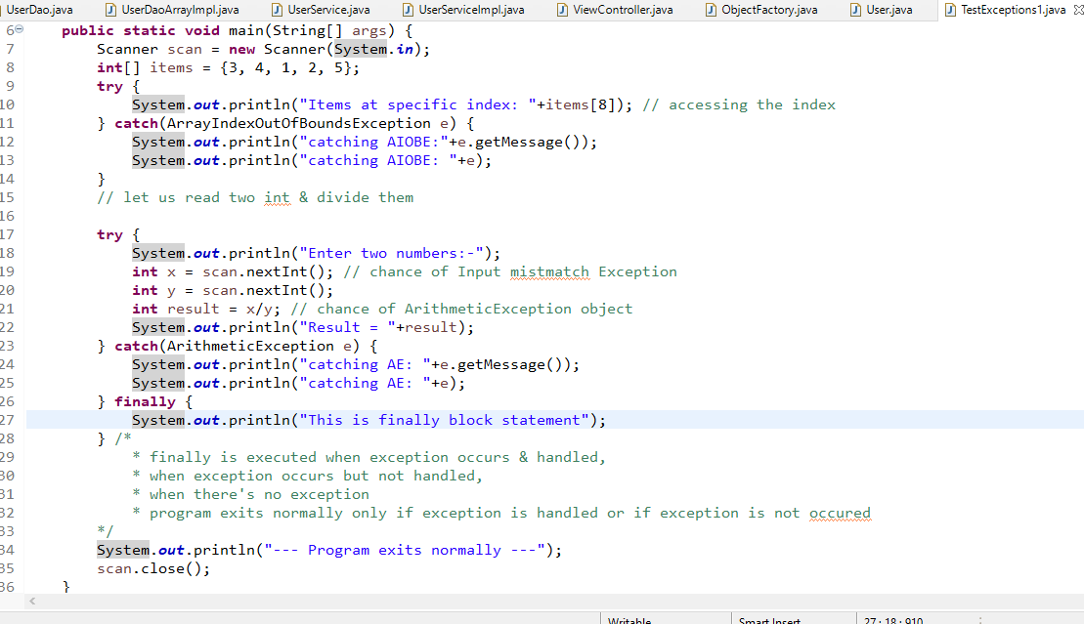

Here the above code needs to have multiple catch blocks to handle the exceptions

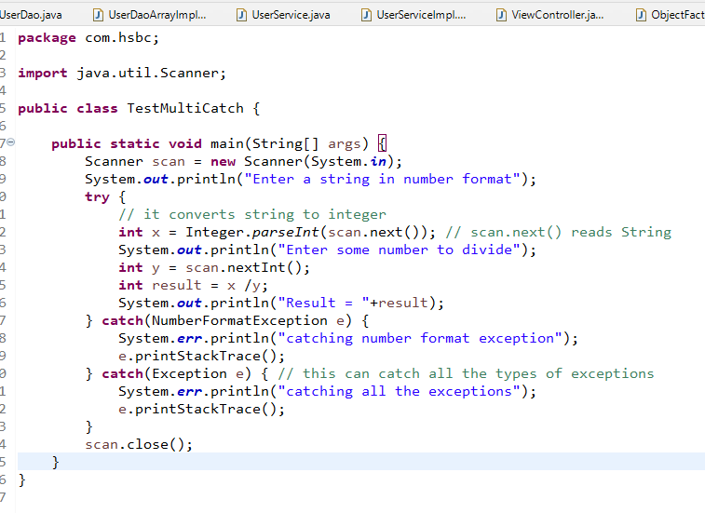

Understanding throw keyword

throw keyword is used to manually generate the exception object

i.e., throw new exception_name();

ex: throw new RuntimException();

ex: throw new ArithmeticException();

ex: throw new ArrayIndexOutOfBoundsException();

Above exceptions throwing doesn’t make sense as java only knows when to create these exceptions i.e., java knows when to throw ArithmeticException() that is when you / by 0, when to throw ArrayIndexOutOfBoundsException() that is when you access the invalid index.

When throw keyword makes sense is when you want to customize the exception, when you want to create your own exception.

How to create customized exceptions or your own exceptions

public class AgeInvalidException extends RuntimeException { } // unchecked exception  
public class AgeInvalidException extends Exception { } // checked exception   
public class EmployeeNotFoundException extends RuntimeException { } // unchecked  
public class EmployeeNotFoundException extends Exception { } // checked

Note: Its advisable to always create customized exception as ‘Checked Exception’

User -> age -> 850 -> throw new AgeInvalidException()

User -> employeeId -> 517 -> throw new EmployeeNotFoundException()

Understanding throws keyword

It is used to propagate the exceptions from the method to another method instead of handling it, so that the caller will know how to handle the exceptions.

When the code gets the exception it can do two things

1. propagate using throws
2. handle using try-catch

syntax:

return_type method_name() throws exception_name, exception_name { ….. }

Note: throws keyword can be used for propagating multiple exceptions or single exceptions.

Note: You can propagate two types of exceptions again i.e., checked & unchecked, but compiler ignores unchecked-exceptions, it will never come to know that the client needs to use try-catch for unchecked-exception

Using throw & throws for predefined exceptions

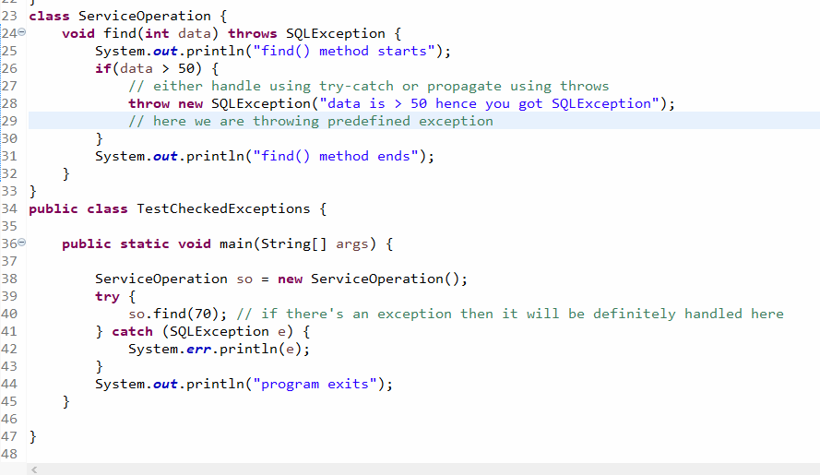

How to create our own exception/custom exceptions and propagate as well as handle it

* You need to extend either Exception or RuntimeException depending on the need
* If you extend Exception it will become Checked Exception, then compiler can recognize it to handle
* If you extend RuntimeException it will become Unchecked Exception, then compiler doesn’t recognize it to handle

AgeInvalidException.java

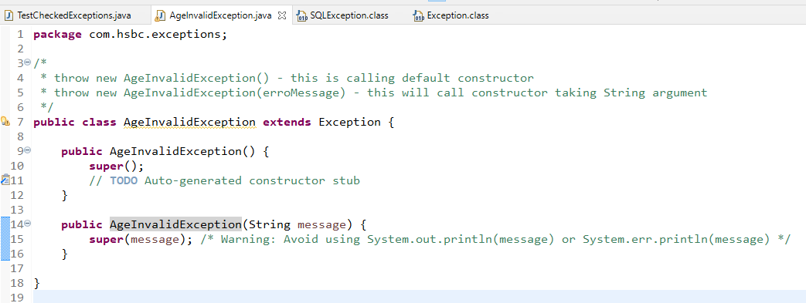

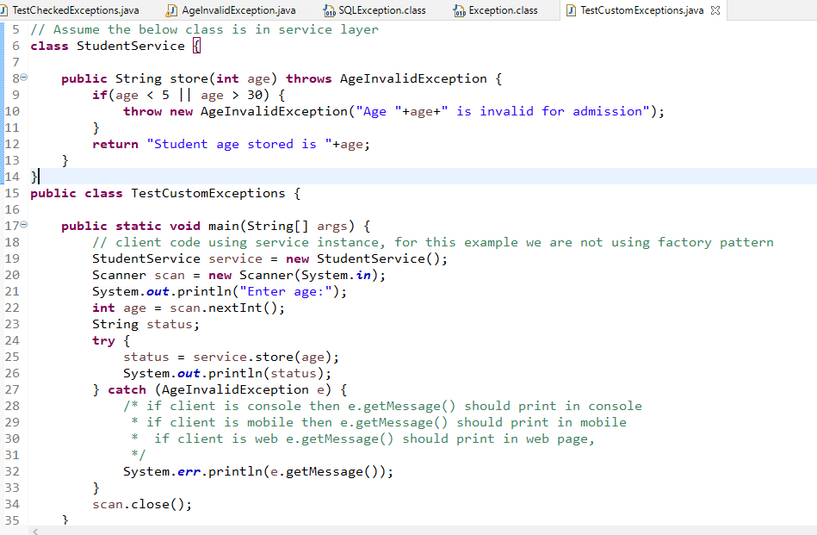

Output:

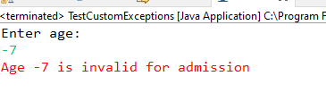

Exercise: In UserApp create a custom exception like UserNotFoundException, so that the view should able to handle and print the exception message if user id is not found

Note: You should force the client to handle UserNotFoundException, i.e., main method should be forced to handle UserNotFoundException while calling fetchUserById()

Solution for UserNotFoundException

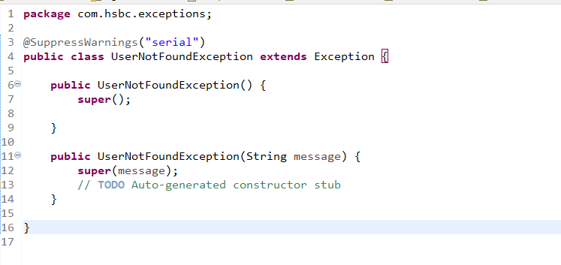

Modify the interfaces to use throws in both dao & service

UserDao.java

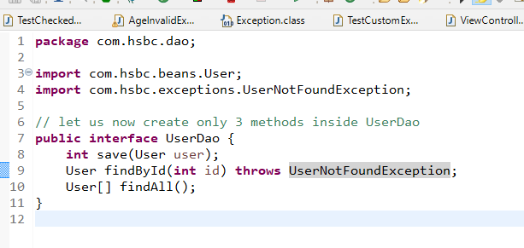

DaoImpl

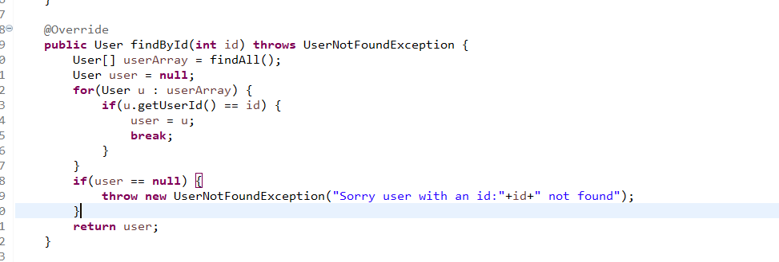

Service

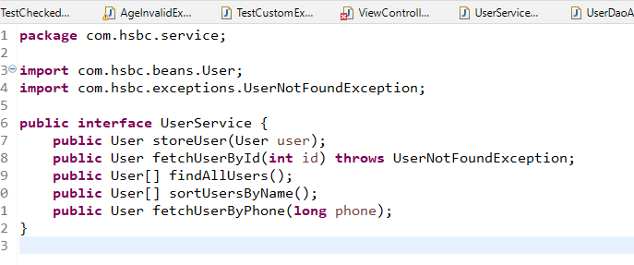

ServiceImpl

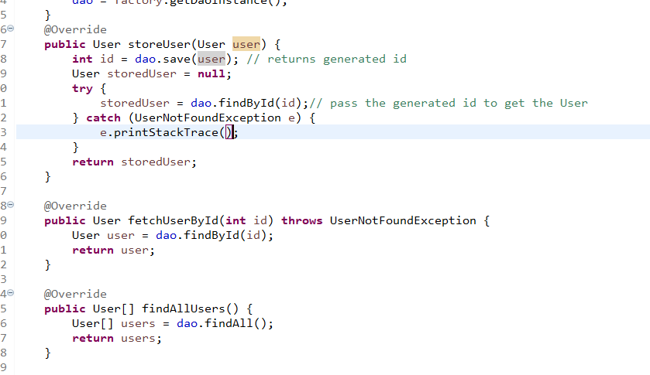

Now in View layer we can call fetchUserById() and handle the UserNotFoundException and print either in web, mobile, desktop, console or any other devices

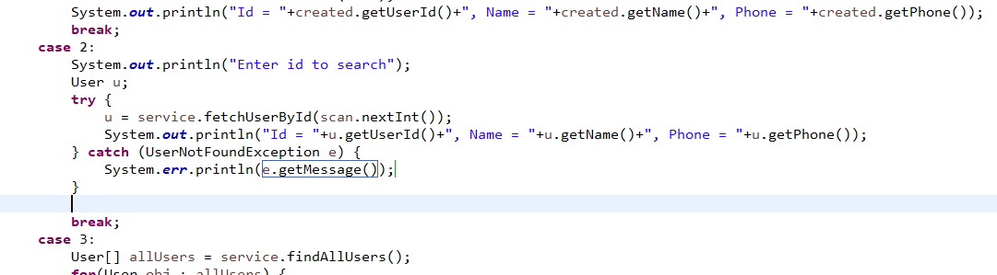

Output:

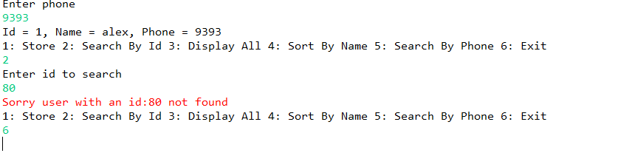

In the user app we are using array but array is fixed in size its not dynamic, i.e., maximum in the above application we can store 25 users

Limitation of arrays

1. arrays size are fixed, it doesn’t increase based on the requirement
2. array can only store same type of element i.e., int[] can only store int, double[] can only store double, User[] it can only store user type data
3. You don’t get any predefined operations like searching, sorting, removing, adding all these you need to manually handle

Collection Framework

Collection is not fixed, it is dynamic and it has lot of predefined interfaces and implementations to maintain the data in different way.

The collection framework provides lot of different methods to perform different operations on the data, which array lacks

Collection Framework interfaces

1. Collection is a root interface, it has methods like
   1. add()
   2. remove()
   3. size()
   4. isEmpty()
   5. clear()
2. List, Set and Queue are the sub-interfaces of Collection
   1. List : Allow duplicates & maintains the elements in sequence order
   2. Set: Allow only unique elements
   3. Queue: Removes the elements in different order like FIFO, Sorted Order, From front & back

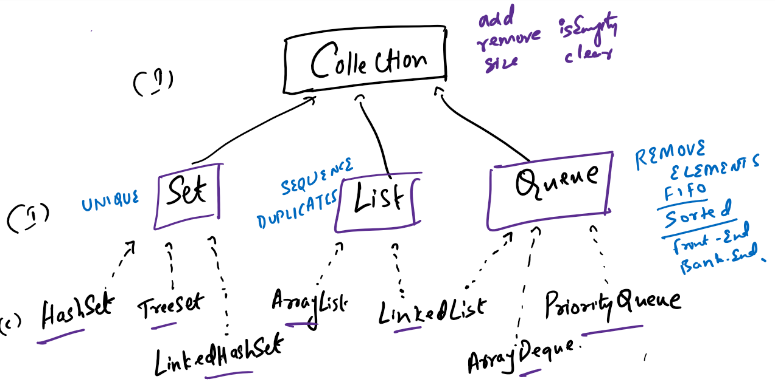

Implementations of Collection

List has 2 implementations

1. ArrayList: Stores elements in contiguous memory address, adding & removing elements is slower but retrieval is faster
2. LinkedList : Stores elements in non-contiguous memory address, adding & removing is faster but retrieval is slower

Both the API’s support duplicates

Set has 3 implementations: All will have only unique elements

1. HashSet: Stores elements in random order but retrieval is faster
2. TreeSet: Stores elements in sorted order - by default uses Ascending order, you can customize using Comparable & Comparator
3. LinkedHashSet: Stores elements in the same sequence you have added

Queue has 3 implementations: It takes care of processing the data after removing

1. LinkedList: removes in FIFO(First In First Out) order
2. PriorityQueue: removes elements in sorted order - by default uses Ascending order, you can customize using Comparable & Comparator
3. ArrayDeque: removes from the Front & Back and also it supports LIFO (Last In First Out).

Map: It is like a collection but stores the elements in key value pairs, however collection only store elements, in Map key is unique but you can have duplicate values.

Map is an interface which has methods like

1. put(key, value) : storing
2. get(key): retrieving value based on key
3. remove(key): remove element based on key

Note: Map is not a part of Collection hierarchy

Map has 3 implementations

1. HashMap: It maintains key in random order
2. TreeMap: It maintains key in sorted order
3. LinkedHashMap: it maintains key in the same sequence you have added

List of common methods of Collection you find in Set, List & Queue

add(T), remove(T), size(), isEmpty(), clear()

Here T is the type of value

How to create instance of Collection implementation, you are going to use Generic type collection

i.e.,

List<Integer> list = new ArrayList<Integer>(); // <Integer> generic specifies you can store int

List<String> list = new ArrayList<String>(); // <String> represents you can store String

List<Employee> list = new ArrayList<Employee>(); // you can store employee instances

List<Integer> list = new LinkedList<Integer>(); // stores int value using linked list

Set<Integer> set = new HashSet<Integer>(); // stores int value in set using HashSet implementation

Set example

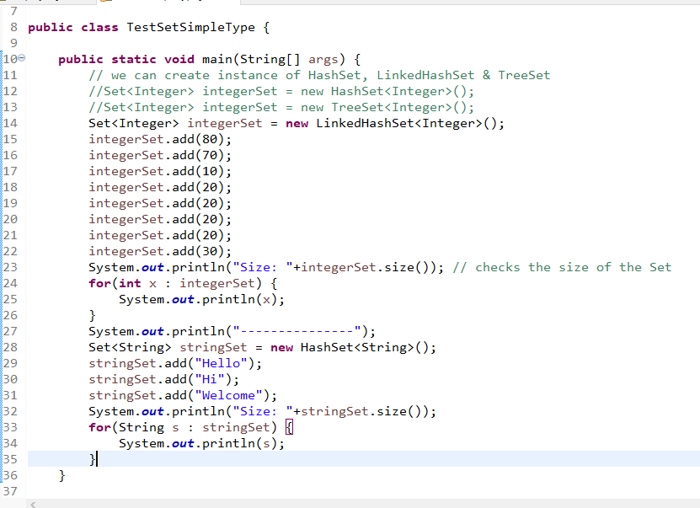

Adding complex types to the collection

You can create one class i.e., java beans with some properties along with that setters & getters also you need to create it

There are three important methods in Object class

1. toString(): it is automatically called when you print object
2. equals(Object): it is used to compare two objects reference
3. hashCode(): it will return an unique id for every object

Exercise: Try to add employee object of having same id to the Set and check what happens

In Employee class override hashCode & equals when you are adding in the Set<Employee>

Using complex types in the TreeSet

Since TreeSet maintains the data in sorted order the complex types should be of Comparable type, else it wouldn’t be sorted, TreeSet calls compareTo() method internally to sort the items, compareTo() method is present in Comparable<T>

How to implement Comparable<T>  
Comparable<T> has method compareTo(T t), which returns an int value

i.e., public int compareTo(T t)

the return type should int which will give the tree set idea about how to sort

if int value is positive, then it is sorted and kept towards right of the compared item

if int value is negative, then it is sorted and kept towards left of the compared item

if int value is 0, then it is not sorted and kept in the middle.

The only thing is you need to give either +ve or -ve or 0 to the TreeSet from compareTo

Employee.java

**package** com.hsbc.beans;

**public** **class** Employee **implements** Comparable<Employee>{

**private** **int** id;

**private** String name;

**private** **double** salary;

**public** Employee() {

**super**();

}

**public** Employee(**int** id, String name, **double** salary) {

**super**();

**this**.id = id;

**this**.name = name;

**this**.salary = salary;

}

**public** **int** getId() {

**return** id;

}

**public** **void** setId(**int** id) {

**this**.id = id;

}

**public** String getName() {

**return** name;

}

**public** **void** setName(String name) {

**this**.name = name;

}

**public** **double** getSalary() {

**return** salary;

}

**public** **void** setSalary(**double** salary) {

**this**.salary = salary;

}

@Override

**public** String toString() {

**return** "Id = "+id + ", Name = " +name+", Salary = "+salary;

}

@Override

**public** **int** hashCode() {

**return** id;

}

@Override

**public** **boolean** equals(Object obj) {

**if** (**this** == obj)

**return** **true**;

**if** (obj == **null**)

**return** **false**;

**if** (getClass() != obj.getClass())

**return** **false**;

Employee other = (Employee) obj;

**if** (id != other.id)

**return** **false**;

**return** **true**;

}

@Override

**public** **int** compareTo(Employee o) {

**int** result = id - o.getId();

**return** result;

}

}

TestComplexTypeSorting.java

**package** com.hsbc;

**import** java.util.HashSet;

**import** java.util.Set;

**import** java.util.TreeSet;

**import** com.hsbc.beans.Employee;

**public** **class** TestComplexTypeSorting {

**public** **static** **void** main(String[] args) {

Employee emp1 = **new** Employee(5, "Alex", 25200);

Employee emp2 = **new** Employee(2, "Charles", 65200);

Employee emp3 = **new** Employee(3, "Bruce", 85200);

Employee emp4 = **new** Employee(1, "Edward", 95200);

Employee emp5 = **new** Employee(4, "David", 99200);

// adding employee objects to the Set - either you can add to HashSet or LinkedHashSet

Set<Employee> employeeSet = **new** TreeSet<Employee>();

employeeSet.add(emp1); // add() -> compareTo on Employee

employeeSet.add(emp2);

employeeSet.add(emp3);

employeeSet.add(emp4);

employeeSet.add(emp5);

**for**(Employee e : employeeSet) {

System.***out***.println(e);

}

}

}

Note: TreeSet will automatically maintain sorted items, however if you want to sort other types like List then you have a class called Collections that provides a sort(list) method.

Note: Collections is a class, Collection is an interface

Now we can use Collection Framework in the DAO layer instead of array in the existing user app program

Dao using List

UserDaoListImpl.java

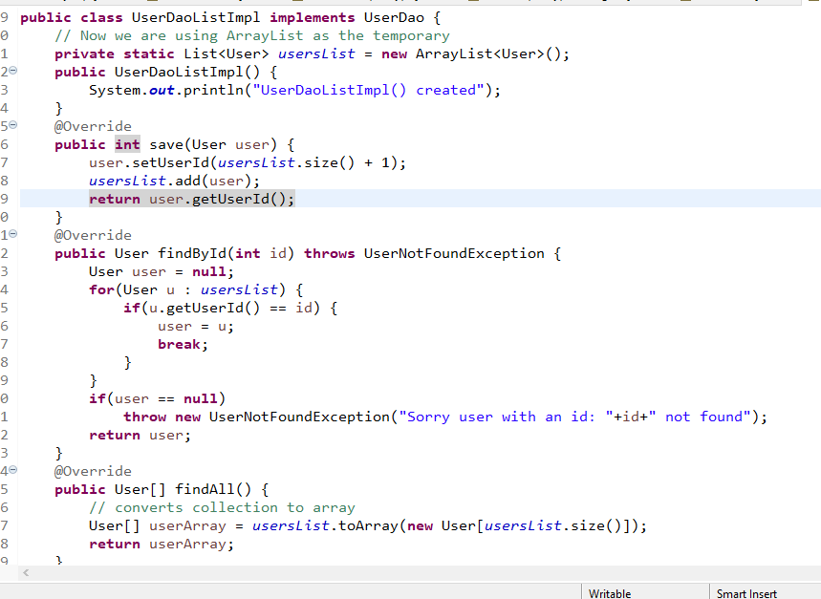

Exercise:

1. Use another DAO that uses TreeSet and instantiate that in Factory pattern
2. Try to create a factory pattern so that without changing the code it can return different dao instance to the service

Hint:

UserDao getDaoInstance(int option) {   
 // return the dao based on the option like for 1 return array for 2 return list for 3 return treeset  
}

UserService getServiceInstance(UserDao dao) { return new UserServiceImpl(dao) }

You need to change the Service layer Implementation to take the UserDao as a parameter

public UserServiceImpl(UserDao dao) { this.dao = dao; }

In View Controller you ask user to enter options like 1, 2, 3 to provide the dao to the service

UserDao dao = objectFactory.getDaoInstance(option);

UserService service = objectFactory.getServiceInstance(dao);

IO Streams

Input Output Streams: it is used to perform read-write operations of stream of data, stream means flow of data, There are two types of streams

1. Byte Streams (Binary data) like images, memory, object
2. Character Streams (Text data) like text files, java files or any readable files

We have set of API’s to read and write different types of streams

1. Byte Streams:
   1. FileInputStream & FileOutputStream : binary files
   2. ObjectInputStream & ObjectOutputStream : objects/memory
   3. BufferedInputStream & BufferedOutputStream: buffer
2. Character Stream:
   1. FileReader & FileWriter: text files
   2. BufferedReader & BufferedWriter: buffer

CharactersStreamIO.java

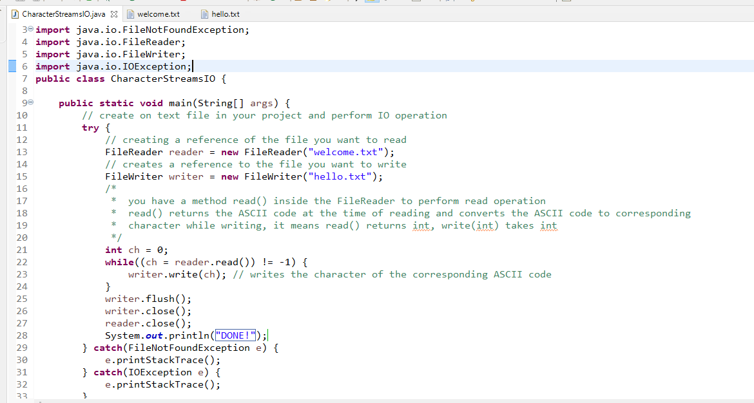

After running refresh the project.

Note: The above program reads every single character & writes every single character to the file, which may give performance issue, that’s we can go with BufferedReader & BufferedWriter which can read / write one line at time instead of one single character at a time.

How to use BufferedReader & BufferedWriter

* you need to pass FileReader & FileWriter references to the BufferedReader & BufferedWriter
* From BufferedReader you need to call readLine() which reads one line from the file
* From BufferedWriter you need to call write() which write one line to the file

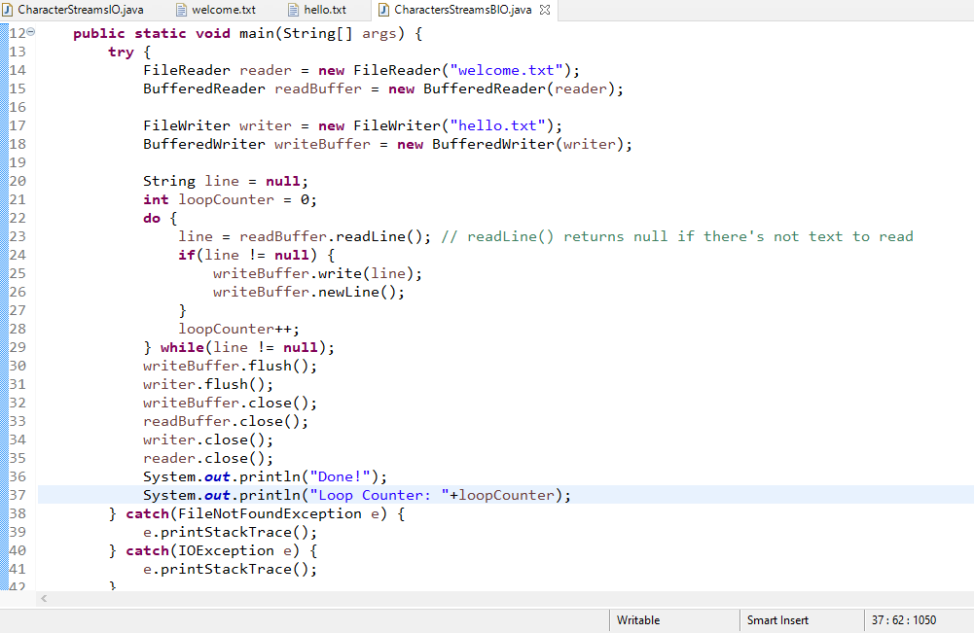

Serialization: Process of writing the object to the filesystem

Deserialization: Process of reading the object from the filesystem

When you want write any object then it must be of Serializable type, in Java we have an interface called Serializable which is a marker interface.

Marker Interface: Those are interfaces which doesn’t have any methods, they are used define the type to the class who they implement

How to do Serialization

You should use ObjectOutputStream class which has a method writeObject(), writeObject() takes any kind of object but checks for Serializable type before writing.

How to do Deserialization

You need to use ObjectInputStream class which has a method readObject() that returns Object type

Employee.java

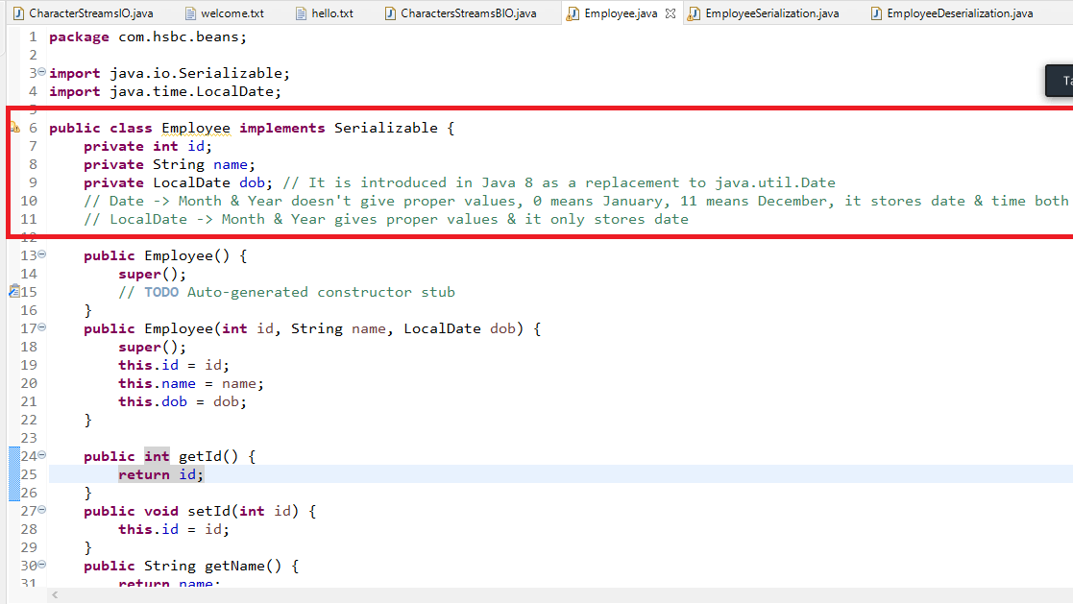

EmployeeSerialization.java

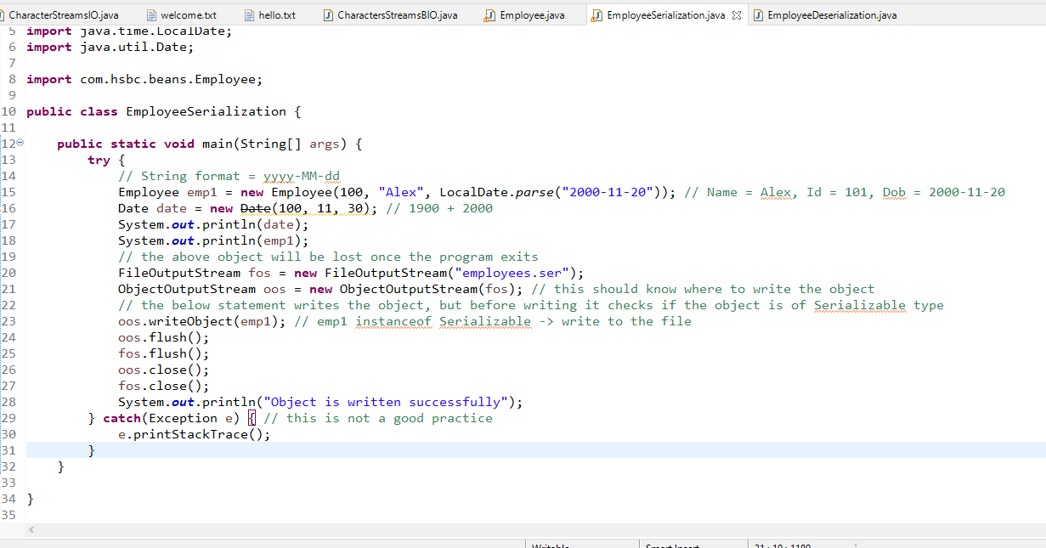

EmployeeDeserialization.java

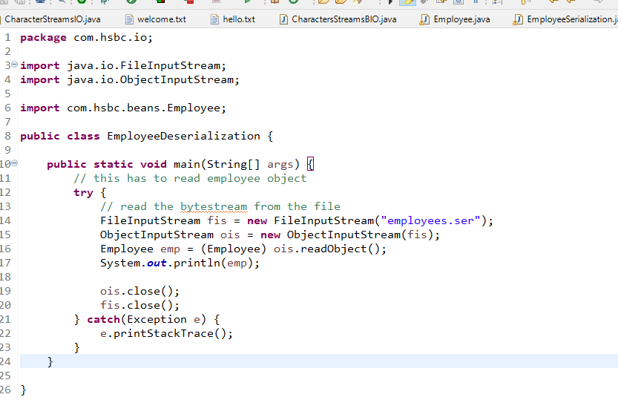

JDBC

Java Database Connectivity, it used to interact with the database using Java, where java programs can send SQL commands to the database to perform any operation.

SQL: Structured Query Language, which is the language the database understands, we have many databases like MySQL, Oracle, Derby, IBMDB2, Sybase and so on.

There are 5 sub-languages in SQL

1. DDL (Data Definition Language): CREATE, ALTER, DROP, TRUNCATE: Deals with structure of the table like creating, dropping, altering, truncating
2. DML (Data Manipulation Language): INSERT, UPDATE, DELETE
3. TCL (Transaction Control Language): COMMIT, ROLLBACK: You can do only on DML statements
4. DQL (Data Query Language): SELECT
5. DCL (Data Control Language): GRANT, REVOKE

Some important SQL commands

mysql> show databases;

+--------------------+

| Database |

+--------------------+

| information_schema |

| mydb |

| mysql |

| performance_schema |

| sys |

| testdb |

+--------------------+

6 rows in set (0.27 sec)

mysql> create database hsbc_db;

Query OK, 1 row affected (0.25 sec)

mysql> use hsbc_db;

Database changed

mysql> show tables;

Empty set (0.15 sec)

mysql> create table demo(name varchar(15), age int);

Query OK, 0 rows affected (1.52 sec)

mysql> insert into demo values('Alex', 34);

Query OK, 1 row affected (0.21 sec)

mysql> select * from demo;

+------+------+

| name | age |

+------+------+

| Alex | 34 |

+------+------+

1 row in set (0.00 sec)

mysql> insert into demo values('Charles', 35);

Query OK, 1 row affected (0.16 sec)

mysql> select * from demo;

+---------+------+

| name | age |

+---------+------+

| Alex | 34 |

| Charles | 35 |

+---------+------+

2 rows in set (0.00 sec)

mysql> insert into demo values('Charles', 35);

Query OK, 1 row affected (0.10 sec)

mysql> select * from demo;

+---------+------+

| name | age |

+---------+------+

| Alex | 34 |

| Charles | 35 |

| Charles | 35 |

+---------+------+

3 rows in set (0.00 sec)

mysql> delete from demo where name = 'Alex';

Query OK, 1 row affected (0.15 sec)

mysql> select * from demo;

+---------+------+

| name | age |

+---------+------+

| Charles | 35 |

| Charles | 35 |

+---------+------+

2 rows in set (0.05 sec)

mysql> insert into demo values('Bruce', 45);

Query OK, 1 row affected (0.10 sec)

mysql> insert into demo values('David', 55);

Query OK, 1 row affected (0.11 sec)

mysql> select * from demo;

+---------+------+

| name | age |

+---------+------+

| Charles | 35 |

| Charles | 35 |

| Bruce | 45 |

| David | 55 |

+---------+------+

4 rows in set (0.00 sec)

mysql> delete from demo where name = 'Charles';

Query OK, 2 rows affected (0.14 sec)

mysql> select * from demo;

+-------+------+

| name | age |

+-------+------+

| Bruce | 45 |

| David | 55 |

+-------+------+

2 rows in set (0.00 sec)

mysql> drop table demo;

Query OK, 0 rows affected (1.08 sec)

mysql> create table employee(id int primary key, name varchar(15), dob date);

Query OK, 0 rows affected (0.56 sec)

mysql> insert into employee values(100, 'Alex', '2000-10-15');

Query OK, 1 row affected (0.18 sec)

mysql> insert into employee values(100, 'Bruce', '1999-12-22');

ERROR 1062 (23000): Duplicate entry '100' for key 'employee.PRIMARY'

mysql> insert into employee values(200, 'Bruce', '1999-12-22');

Query OK, 1 row affected (0.16 sec)

mysql> create table users(userid int primary key auto_increment, name varchar(15), dob date);

Query OK, 0 rows affected (1.13 sec)

mysql> insert into users(name, dob) values('Ajay', '2000-09-18');

Query OK, 1 row affected (0.21 sec)

mysql> insert into users(name, dob) values('Zaheer', '2001-09-19');

Query OK, 1 row affected (0.13 sec)

mysql> select * from users;

+--------+--------+------------+

| userid | name | dob |

+--------+--------+------------+

| 1 | Ajay | 2000-09-18 |

| 2 | Zaheer | 2001-09-19 |

+--------+--------+------------+

2 rows in set (0.00 sec)

mysql> create table users2(userid int primary key auto_increment, name varchar(15), dob date)auto_increment=200;

Query OK, 0 rows affected (1.58 sec)

mysql> insert into users2(name, dob) values('Zaheer', '2001-09-19');

Query OK, 1 row affected (0.09 sec)

mysql> select * from users2;

+--------+--------+------------+

| userid | name | dob |

+--------+--------+------------+

| 200 | Zaheer | 2001-09-19 |

+--------+--------+------------+

1 row in set (0.00 sec)

mysql> select * from employee;

+-----+-------+------------+

| id | name | dob |

+-----+-------+------------+

| 100 | Alex | 2000-10-15 |

| 200 | Bruce | 1999-12-22 |

+-----+-------+------------+

2 rows in set (0.03 sec)

mysql> insert into employee values(300, 'Bobby', '2001-10-22');

Query OK, 1 row affected (0.10 sec)

mysql> insert into employee values(400, 'Bob', '2002-10-22');

Query OK, 1 row affected (0.14 sec)

mysql> select * from employee;

+-----+-------+------------+

| id | name | dob |

+-----+-------+------------+

| 100 | Alex | 2000-10-15 |

| 200 | Bruce | 1999-12-22 |

| 300 | Bobby | 2001-10-22 |

| 400 | Bob | 2002-10-22 |

+-----+-------+------------+

4 rows in set (0.05 sec)

mysql> select * from employee where id = 300;

+-----+-------+------------+

| id | name | dob |

+-----+-------+------------+

| 300 | Bobby | 2001-10-22 |

+-----+-------+------------+

1 row in set (0.00 sec)

mysql> select * from employee where name = 'Bob';

+-----+------+------------+

| id | name | dob |

+-----+------+------------+

| 400 | Bob | 2002-10-22 |

+-----+------+------------+

1 row in set (0.00 sec)

mysql> select * from employee where name like 'Bo%';

+-----+-------+------------+

| id | name | dob |

+-----+-------+------------+

| 300 | Bobby | 2001-10-22 |

| 400 | Bob | 2002-10-22 |

+-----+-------+------------+

2 rows in set (0.05 sec)

mysql> select * from employee;

+-----+-------+------------+

| id | name | dob |

+-----+-------+------------+

| 100 | Alex | 2000-10-15 |

| 200 | Bruce | 1999-12-22 |

| 300 | Bobby | 2001-10-22 |

| 400 | Bob | 2002-10-22 |

+-----+-------+------------+

4 rows in set (0.00 sec)

mysql> update employee set name = 'Brad' where name = 'Bob';

Query OK, 1 row affected (0.13 sec)

Rows matched: 1 Changed: 1 Warnings: 0

mysql> select * from employee;

+-----+-------+------------+

| id | name | dob |

+-----+-------+------------+

| 100 | Alex | 2000-10-15 |

| 200 | Bruce | 1999-12-22 |

| 300 | Bobby | 2001-10-22 |

| 400 | Brad | 2002-10-22 |

+-----+-------+------------+

4 rows in set (0.05 sec)

mysql>

Layered Architecture

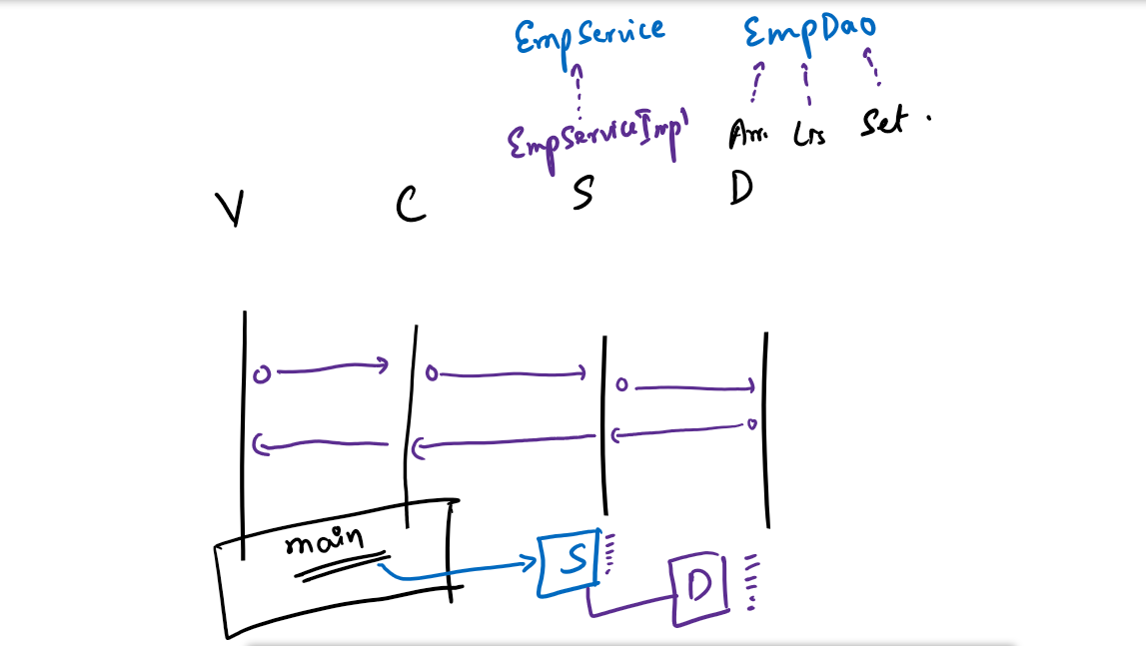

JDBC

JDBC stands for Java Database Connectivity, it provides JDBC API’s which are set of classes & interfaces that works with any RDBMS, these JDBC APIs are implemented by every database vendors and they provide the jar to the developers using which they can interact with their database, suppose if you want to use mysql database you need to use the jars provided by mysql, if you are using oracle database you need to use the jars provided by oracle.

JDBC uses JDBC drivers to interact with the database, jdbc drivers are the implementation of JDBC API’s, these drivers are provided in the jar file of every database.

Steps to interact with the database

There are 5 steps you need to perform inorder to interact with the database using JDBC

1. Loading the JDBC driver

Class.forName(driverName); // driverName is fully qualified class name

1. Connecting to the database

Connection con = DriverManager.getConnection(url, username, password);

url: database url

username: username of the database

password: password of the database

1. Create the statements : This allows you to write SQL commands

Statement stmt = con.createStatement();

1. Execute the statements: This allows you to execute SQL commands

int r = stmt.executeUpdate(dmlCommands); // insert, update & delete

ResultSet rs = stmt.executeQuery(drlCommands); // select

Since select commands can generate zero or more records you can use methods of ResultSet to navigate and extract data from each column

rs.next() -> it navigates to the next record if true

rs.getString(columnIndex) -> it returns the String value from the specified column index but column must be of type varchar

rs.getInt(columnIndex) -> it returns the int value from the specified column index

rs.getDouble(columnIndex) -> it returns the double value

rs.getDate(columnIndex) -> it returns the Date of java.sql type

1. Close the database resources

rs.close();

stmt.close();

con.close();

In realtime developers use Maven projects, it can download the dependent jars from the internet.

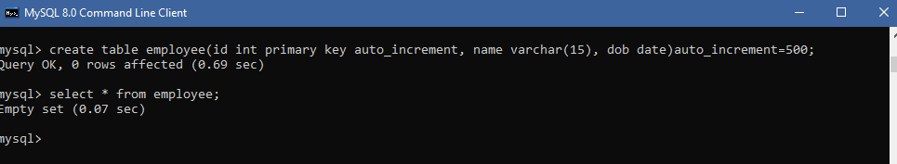

TestStoring.java

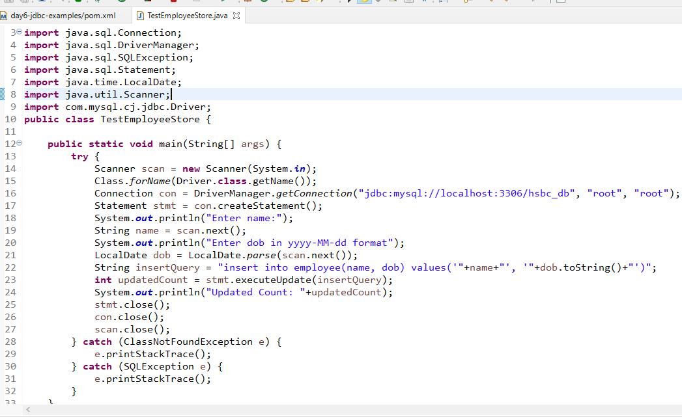

The above program is taking employee data directly from the keyboard but we can create an Employee class & initialize employee properties

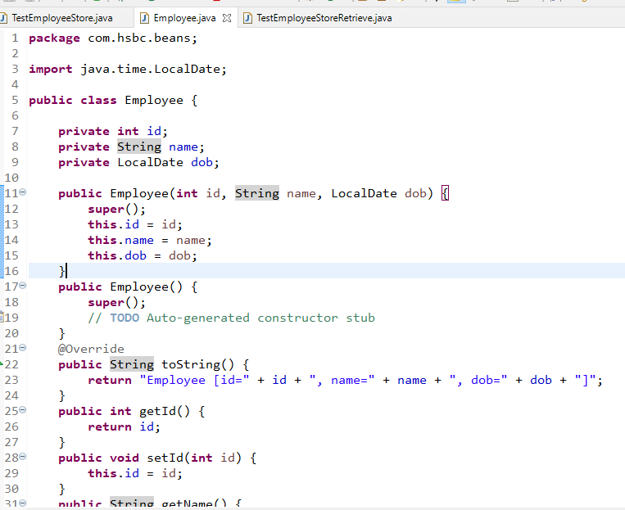

Storing & Retrieve Program

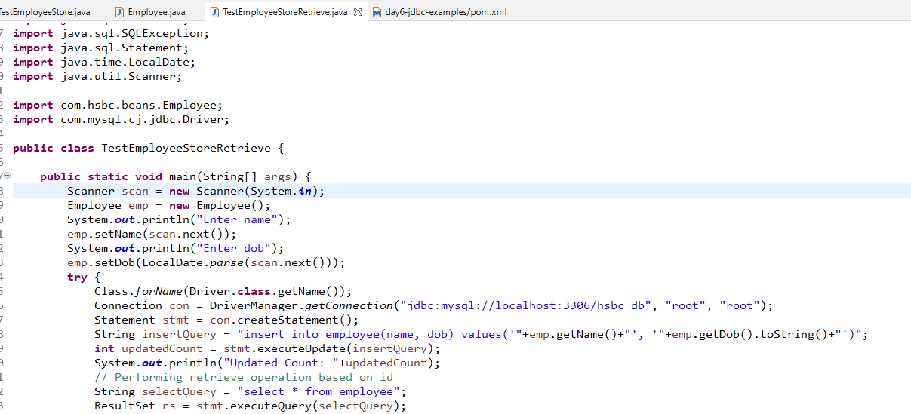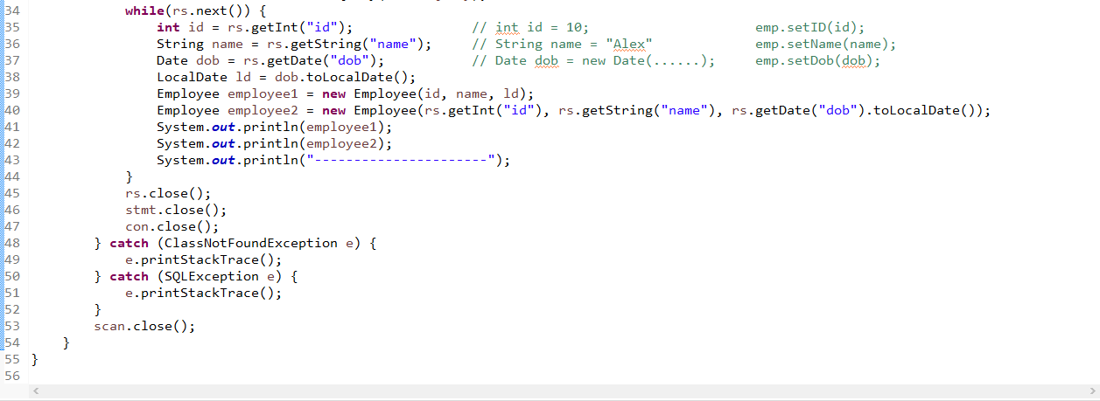

Statement is complex to write when it comes to adding dynamic values, hence we have another type of Statement called PreparedStatement which is better when you have dynamic values, because it uses place holder ‘?’ that can be replaced by PreparedStatement methods

Statement stmt = con.createStatement();

query = "insert into employee(name, dob) values('"+emp.getName()+"', '"+emp.getDob().toString()+"')";

stmt.executeUpdate(query);

With prepared statement you can avoid these string concatenation.

query = “insert into employee(name, dob) values(?, ?)”;

PreparedStatement pstmt = con.prepareStatement(query);

// now you can set values to the ? using setter methods of PreparedStatement for each datatype of java

pstmt.setString(1, “Alex”); // 1 will map to 1st ?

pstmt.setDate(2, LocalDate.parse(“1999-10-18”)); // 2 will map to 2nd ?

Now the query in the prepared statement will be modified to

“insert into employee(name,dob)values(‘Alex’, ‘1999-10-18’);

Now the prepared statement can be executed using executeUpdate() of PreparedStatement

pstmt.executeUpdate(); //

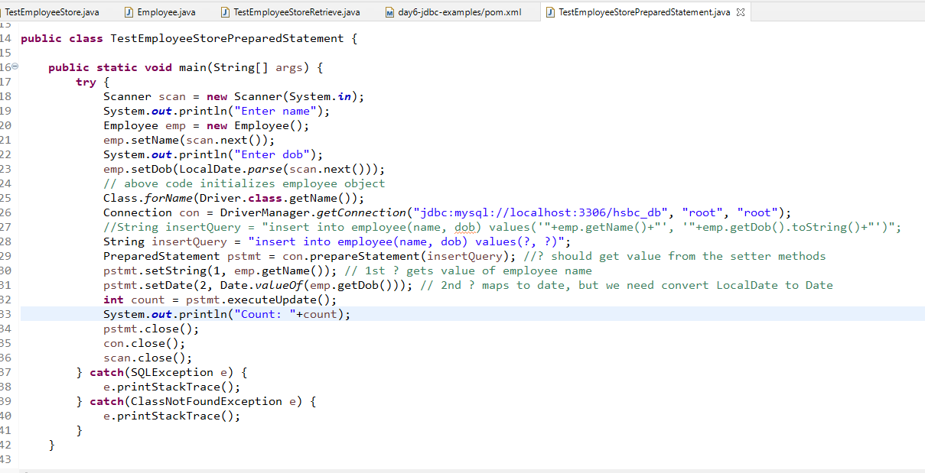

Same program how to do with the layered architecture

1. You need to add database operations all the JDBC steps in the DAO layer
2. You need to reuse Connection logic in a separate class so that DAO layer can reuse it
3. Scanner & System.out.println should in the ViewController

How to reuse the connection

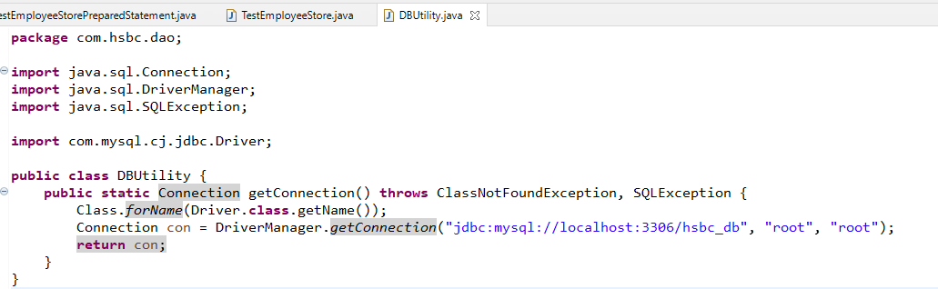

How to call the method

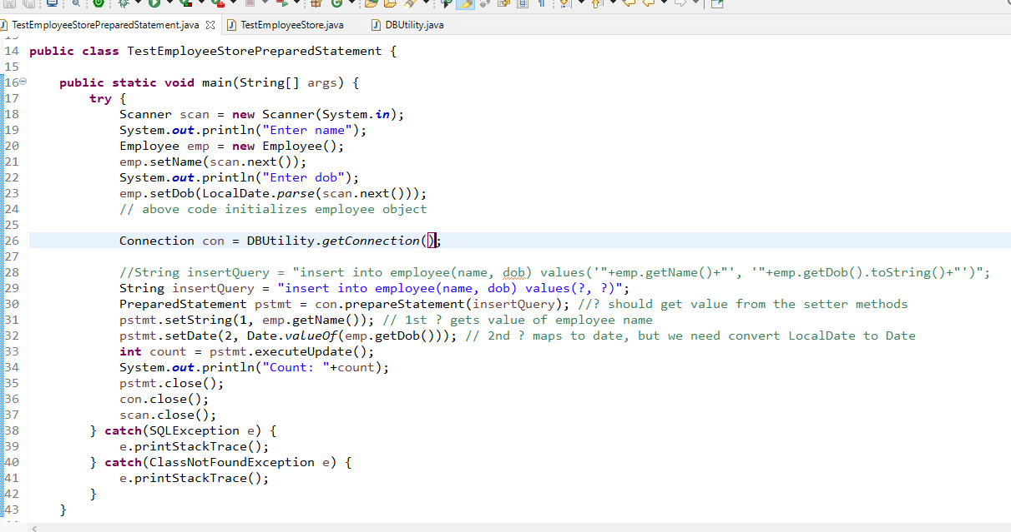26th line is reusing the Connection logic

Transaction in JDBC

Transaction will allow the program to take care of commit and rollback based on the success & failure status of the database operation

In JDBC all the DML statements are auto committed i.e., they are auto-saved by default

pstmt.executeUpdate(); // updates the record in the table & auto-commits

You can have control over the transaction by using setAutocommit(false) which is the method present in Connection, later you can use commit() & rollback() of Connection.

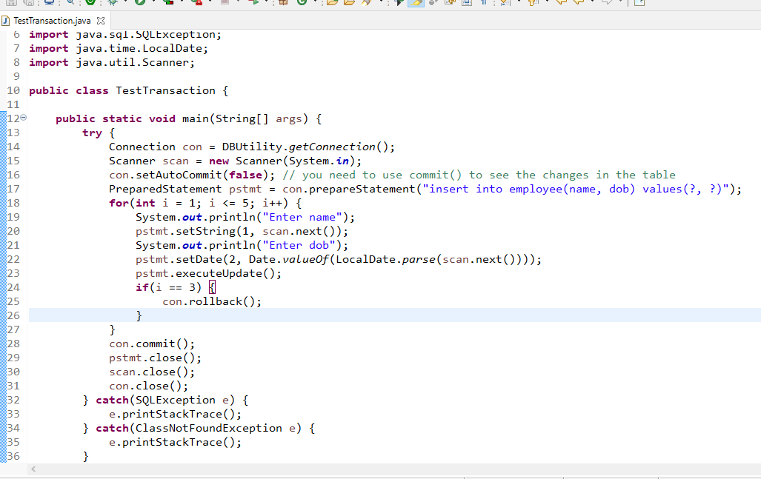

Above program rollbacks first 3 record & commits last 2 records

Implementing the existing user-app using JDBC

Creating the table for users

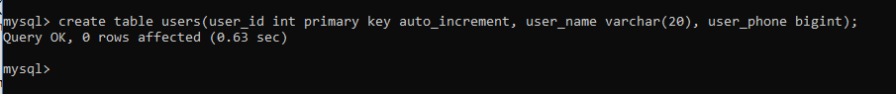

Implement UserDao in the DAO layer and factory pattern can return the instance of Jdbc implementation based on the option

Multithreading: Performing more than one task at the same time in the same program or application

There are two types of multi-tasking

1. Multi-Processing: Multiple programs running at the same time:

Ex: Windows OS can run multiple programs at the same time, like Notepad, Word Document, Eclipse, Mysql terminal

1. Multi-Threading: Single program that can perform more than one task at the same time

Ex: MS Word being a single program can perform multiple tasks at the same time like typing, auto-correct, spell check, line break, indentations

In Multi-threading you can create more than one methods and run simultaneously or a single method that are run by multiple threads

How to create multithreaded programs

There are two ways you can create multithreaded program

1. Thread class - you can extend Thread class & override run method
2. Runnable interface - you can implement Runnable interface & override run method

Here run() is an entry-point for every threads to begin the task, all the multithreaded tasks should begin from run()

Thread class is used to create Threads & start threads using some of the inbuilt method like start()

How to create threads

Thread t = new Thread(runnableTypeObject);

// register the thread in the CPU thread schedular

t.start(); // this registers the thread in the thread schedular

TestThreading.java

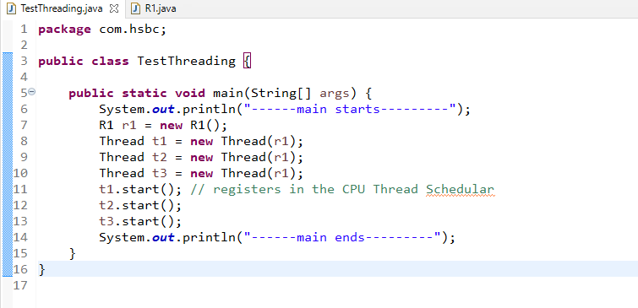

R1.java

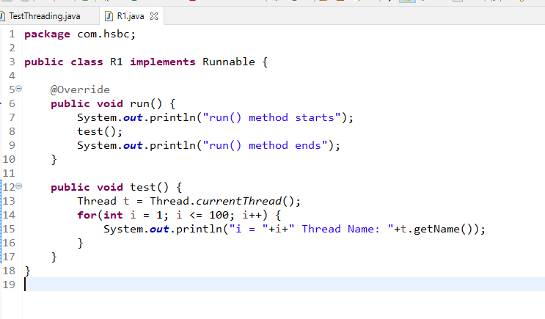

Here the test() method will be called by 3 different threads

The thread name starts with Thread-0, Thread-1, …. Thread-N

We can also change the thread name

setName(threadName);

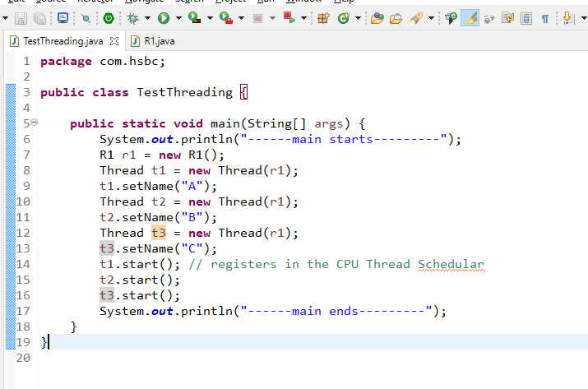

Synchronization: Process in multithreading that allows one thread at a time to perform a specific task instead of multiple threads performing simultaneously

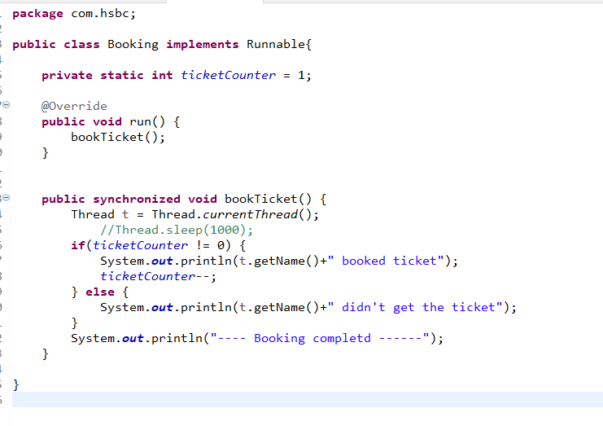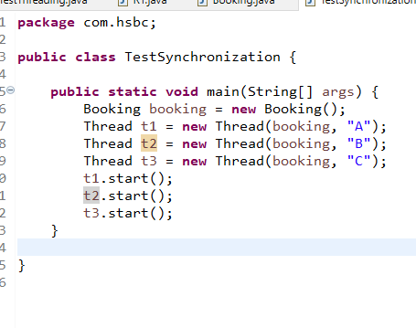

Web Technologies

1. HTML
2. CSS
3. Javascript
4. Servlets
5. JSP

HTML stands for Hyper Text Mark Up Language, it is mainly used for displaying the content on the web page

CSS stands for Cascading Style Sheet, it is mainly used for styling the content or HTML elements

Javascript is mainly used to access HTML & CSS at runtime and also for client side validation

Servlets & JSP is mainly used to develop dynamic web pages and to develop server side programs

A simple HTML example

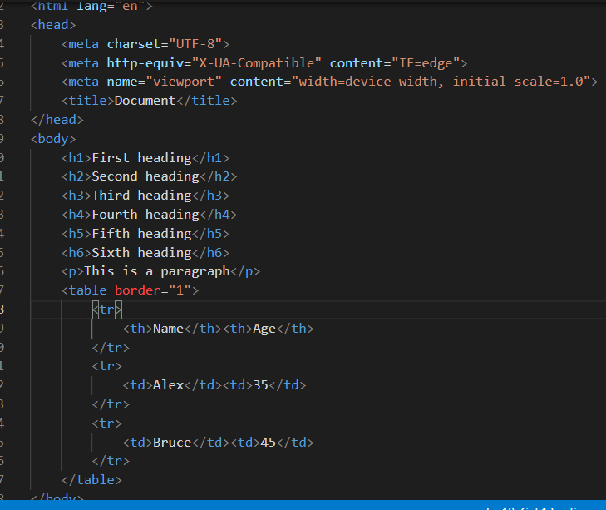

ImagesDemo.html

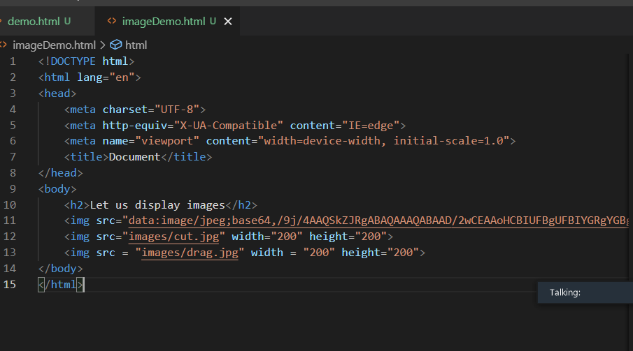

CSS syntax:

You can develop 3 types of CSS

1. External CSS: A ‘.css’ file is created and multiple HTML can use it
2. Internal CSS: Styles are written in the <style> tag of HTML <head> it is unique to the particular HTML document
3. Inline CSS: A style for a particular element

For External & Internal CSS

selector { property : value; property : value; }

selector: A tag or an id or a class

property: css properties like color, background-color, border

value: a value to the property, it depends on property

For Inline CSS

<element-name style = ‘property: value; property: value’>….</element-name>

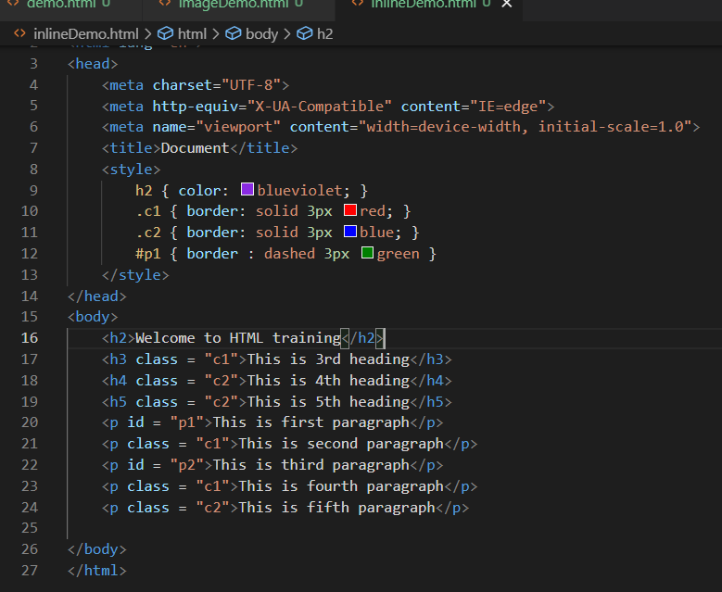

Output:

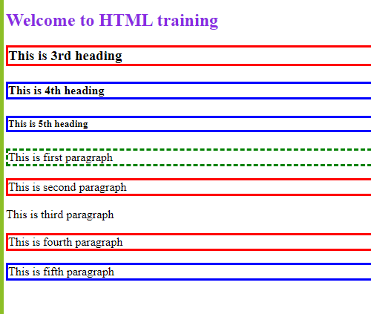

External CSS demo

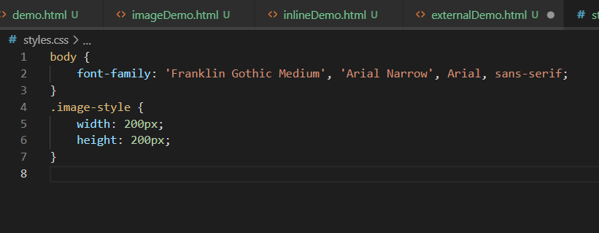

external css

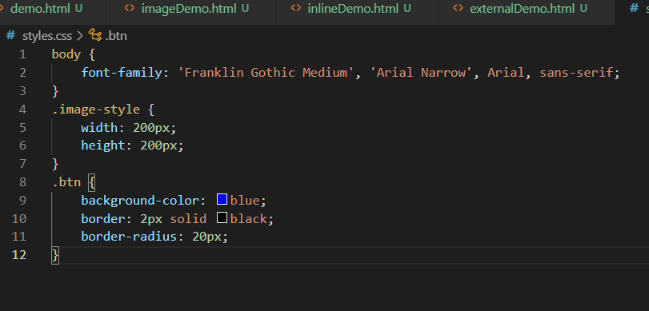

Linking external css to the HTML using <link>

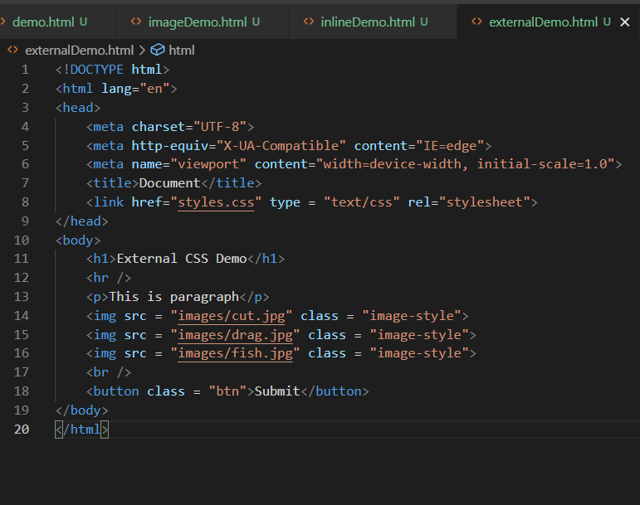

Form tag is used to create form controls like textbox, password box, check box, radio button, submit button, reset button

Form Demo

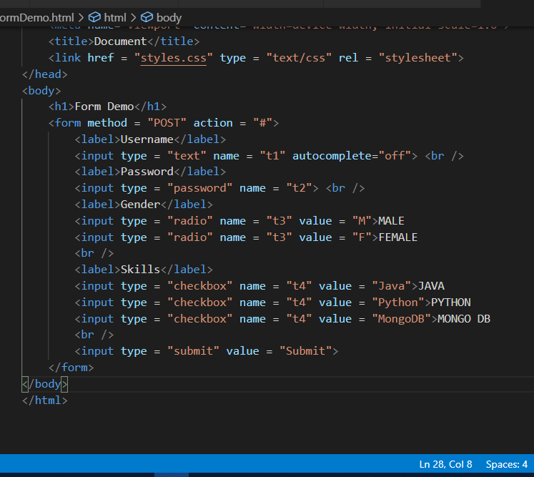

Javascript:

It is a scripting language allows you to write programs to access HTML elements & CSS properties, Using javascript you can

* Modify the HTML & CSS
* Client side validations like checking for empty data, checking length of the characters, comparing the contents and so on
* Add dynamic behaviour to your web page

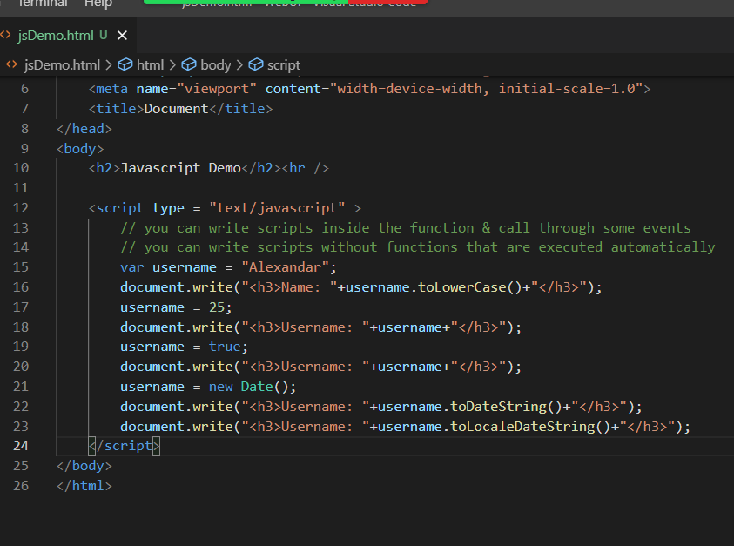

In Javascript you can write programming constructs like

* if
* if else
* switch
* for loop
* while
* do while
* arrays

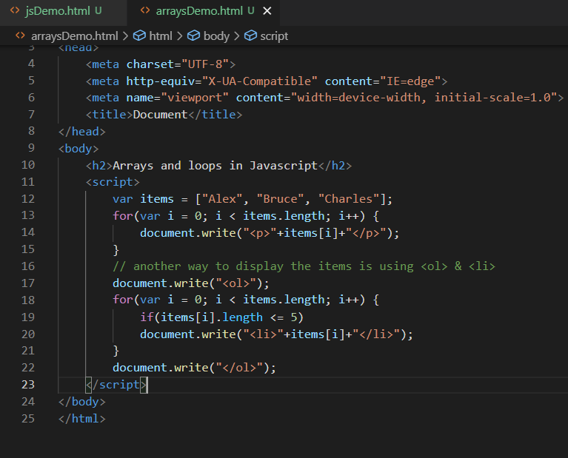

In Javascript you can create functions & call through some events

onclick, onmouseover, onmouseout, onsubmit, onload

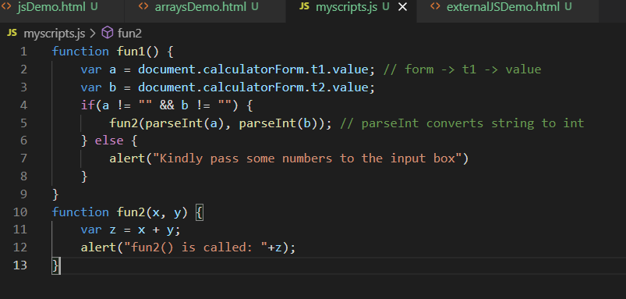

HTML

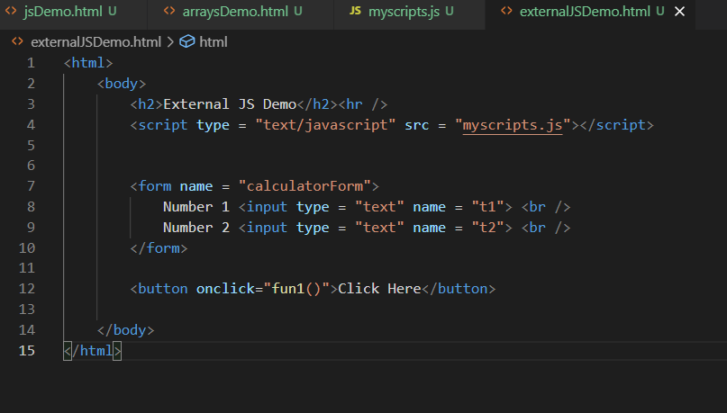

We can add CSS properties through Javascript by accessing HTML element via id

document.getElementById(“idValue”) : returns the HTML element having the id

document.getElementById(“idValue”).innerHTML : returns the content of the HTML element and also you can modify it from the below code

document.getElementById(“idValue”).innerHTML = ‘hello world’;

The above code adds hello world to the HTML element having the matching id

document.getElementById(‘idValue’).style;

The above code adds style attribute to the HTML element having the matching id

document.getElementById(‘idValue’).style.color = ‘red’;

The above code adds style with property color & value red to it

document.getElementById(‘idValue’).style.backgroundColor = ‘blue’

The above code adds style with property background-color & value blue

For every css styles we have corresponding javascript style’s that you can access only if you access to element

|  |  |
| --- | --- |
| CSS | Javascript |
| color | color |
| background-color | backgroundColor |
| font-size | fontSize |

Form Validation

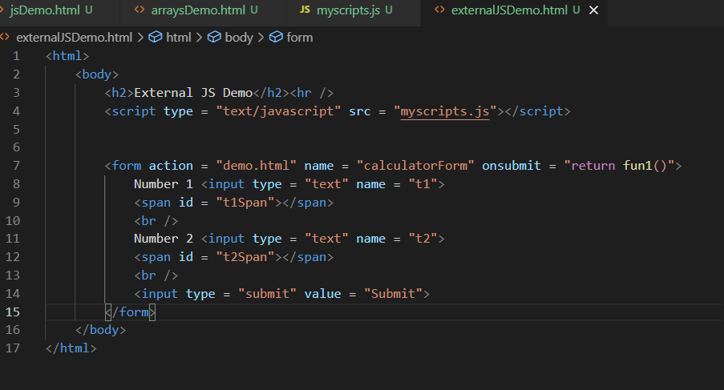

External JS

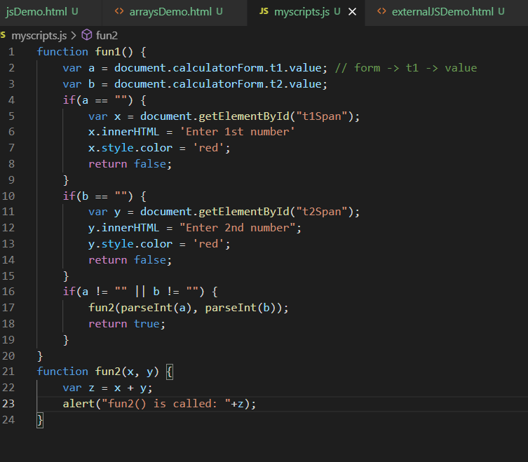

Exercise

1. Load the images to the bigger area when you click on the images present in the smaller area

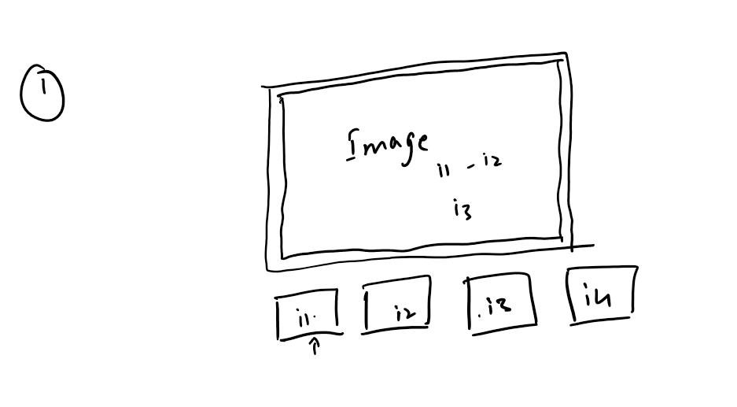

1. Validation the registration form

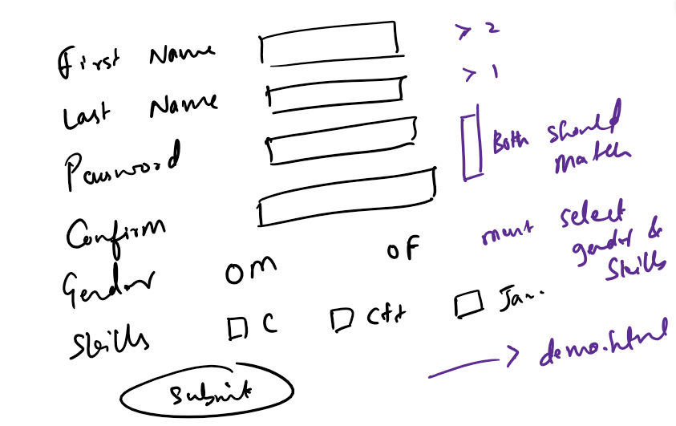

Tomcat Server: It is an HTTP server that can host your web applications, you can configure tomcat in eclipse in Java EE perspective or manually also you can run the tomcat server.

Every web application tomcat hosts is accessed using the ip and port of the tomcat server, by default tomcat server takes 8080 port number

AJAX: Asyncrhonous Javascript and XML, which is used to partially update the webpage by loading the content from the server

ex: Google search engine, Facebook apps, Twitter app and so on

AJAX can easily parse XML or JSON to Javascript language.

JSON stands for Javascript Object Notation, which represents the data similar to javascript objects, but JSON is understood by every programming language in the world to convert from JSON to the respective language like JSON to Java, JSON to Javascript, JSON to C# and so on.

How does JSON looks

JSON is similar to Javascript objects structure

{“key”:value, “key”: value} -> JSON

{key: value, key : value} -> Javascript

Array of JSON

[

{“key”:value, “key”:value,….},

{“key”:value, “key”:value}

]

How to convert JSON to Javascript

JSON.parse(jsonData): parse method takes JSON string and converts to Javascript object

To make AJAX calls we need to have a server to send request to another server, i.e., our javascript code should be running inside the server

We can make AJAX call using XmlHttpRequest, when you send the request the object changes its state from 0 to 4

0 -> request not initialized

1 -> request initialized

2 -> request sent

3 -> request is processing

4 -> response is received

XmlHttpRequest object has some properties

onreadystatechange: this is a property that is going to call some function for every state change

readyState: this property gives the state number

reponseText: returns the JSON value

responseXML: returns the XML value

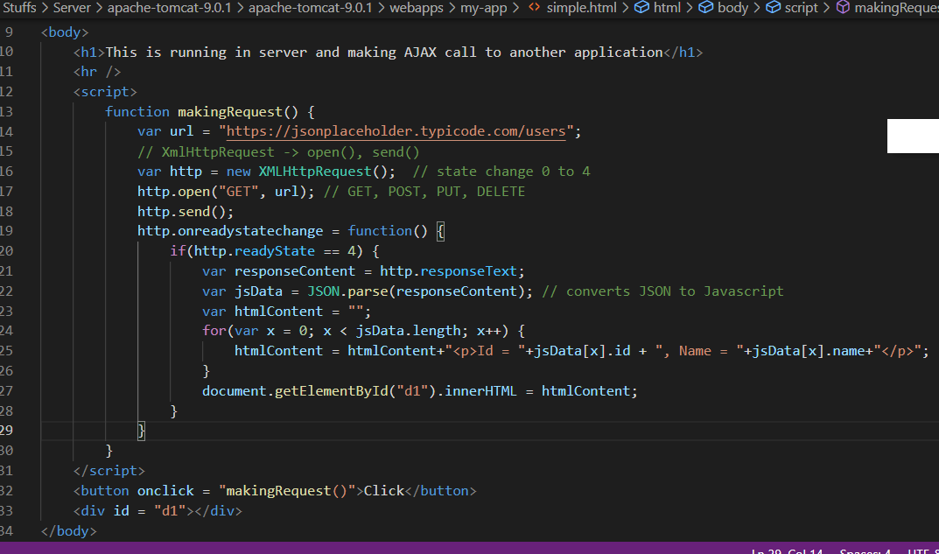

How to create web applications in the eclipse

1. Create Dynamic Project
2. Ensure server is selected

Once project is created you will have two main folders

1. Java Resources/src: All your java files
2. Web Content: All the HTML, CSS, JS, JSP files

Excercise1: Complete the same example shown

Excercise2: use the employees.json file and write an AJAX call program to get the data from the JSON file & display the data in a table format

Servlets

Servlets are java programs that are executed at the server side, it can process the request and generate the response, it is mainly used to create dynamic web pages

Inorder to develop Servlet you need to implement Servlet interface, it has 5 abstract methods in it.

1. init(ServletConfig): initialization logic, called when servlet object is created
2. service(ServletRequest, ServletResponse): is called for every request
3. destroy(): is called when servlet object is removed
4. getServletInfo(): is called when you want to get the servlet information
5. getServletConfig(): is called when you want to know the configuration done to the Servlet

Java has provided two more classes that are part of Servlet

1. GenericServlet implements Servlet: it has overridden all the methods except service();
2. HttpServlet extends GenericServlet: It has overridden service() to provide logic to handle HTTP protocol

As a developer you need to use HttpServlet which is already handling HTTP protocol, it has provided some methods like doGet(), doPost() that are called whenever the request comes, doGet() is called when the request is coming through the URL, doPost() is called when the request is coming through body of the document

Servlet Architecture

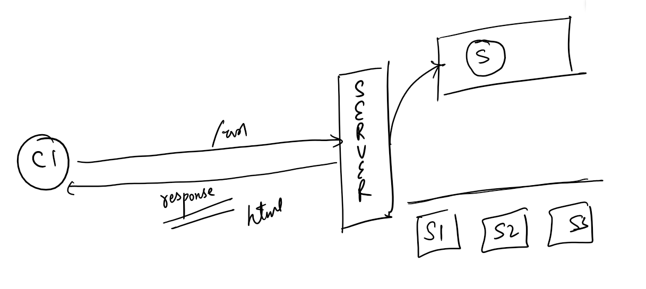

Servlet has 3 lifecycle methods

1. init()
2. service()
3. destroy()

How to create a Servlet

1. Dynamic Web Project
2. Ensure server is configured
3. Create Servlet using Servlet option available

index.html

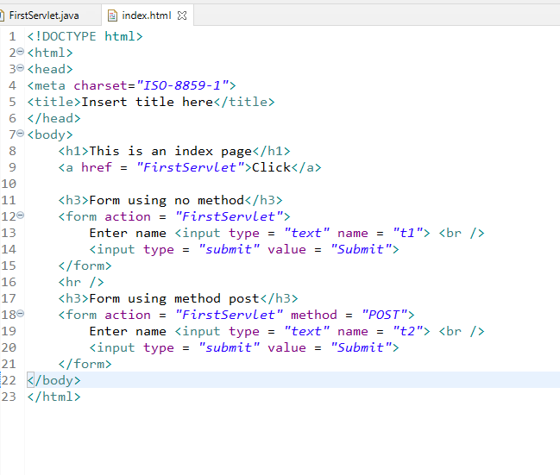

FirstServlet

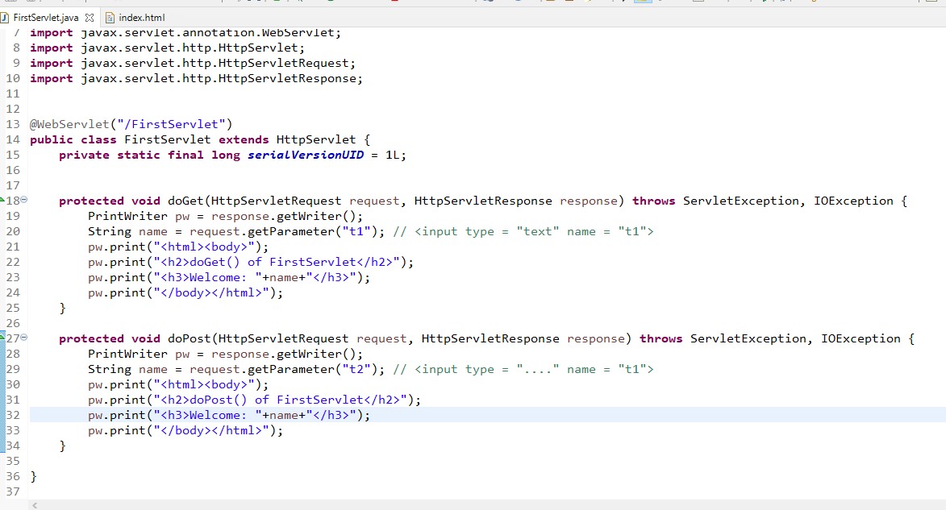

Output:

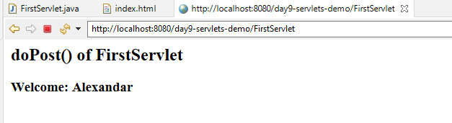

Exercise:

Create another servlet with the name SecondServlet and create a form that sends to input name and password, display the name & password via doPost

Get vs Post

|  |  |
| --- | --- |
| GET | POST |
| Sends data through the Request URL | Sends data through the Request Body |
| Insecure | Secured |
| Supports only 256 characters data | Unlimited characters of data |
| Faster | Slower compare to GET |
| Default method of form submission | Form need explicitly use method = “post” |
| Can send GET request via <a> <form> and also through AJAX calls | Can send POST request via <form> and also through AJAX calls |

MVC design pattern

It is one of the widely used design pattern when building the web application, it concentrates on separation of concerns where you can separate View (Presentation) Model (Business and Resource) and Controller(Navigation) logics so that its easier to maintain the application, it gives us n-tier or layered architecture where each layer concentrates on specific task or concern so that changes made in one layer doesn’t force to modify other layers.

View: It mainly concentrates on the presentation logic or User Interface you can use HTML, JSP, Javascript or any client side applications like Angular framework/React.js/Vue.js/Ext.js and etc

Controller: It mainly concentrates on the navigation logic & processing the request i.e., what should be the next view when the request comes from the client, you can use Servlets/Controller classes in Spring framework

Model: It mainly concentrates on Business logic & Resource logics i.e., DB logics, you can use Service and DAO classes with interfaces

Factory Pattern: It is always recommended to use some design patterns to avoid some commonly occurring problems, in that factory pattern is one design pattern which takes care of object creation for different dependencies i.e., Service depends on DAO, Controller depends on the Service

Request Dispatcher: It is an object to dispatch the request to another resource could be Servlet or HTML or JSP, In Servlet we have an interface RequestDispatcher that provides two methods

1. forward(request, response)
2. include(request, response)

Note: RequestDispatcher is already implemented by the server, we just need to use the RequestDispatcher reference

How to create RequestDispatcher

*RequestDispatcher rd = request.getRequestDispatcher(“url-pattern”)*

You can call the methods of RequestDispatcher like forward() or include

rd.forward(request, response);

rd.include(request, response);

When you create RequestDispatcher it only knows the destination resource location where the request should be dispatched, by calling forward() or include() the request would be dispatched

forward(request, response): It shows the destination resource content to the end user and ignores the content of the source(servlet that created RequestDispatcher)

include(request, response): It includes the destination resource content in the source content and shows both the content to the end user

Demo on RequestDispatcher

1. index.html : for welcome page
2. login.html: allows user to enter username & password
3. LoginServlet: takes the request from login.html and forwards to SuccessServlet if username & password is correct else includes login.html + its content
4. SuccessServlet: takes the request from LoginServlet and displays the success message

index.html

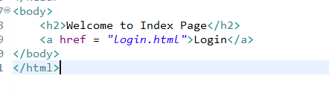

login.html

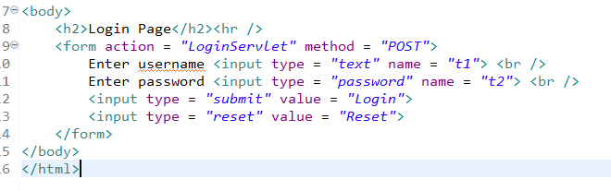

LoginServlet

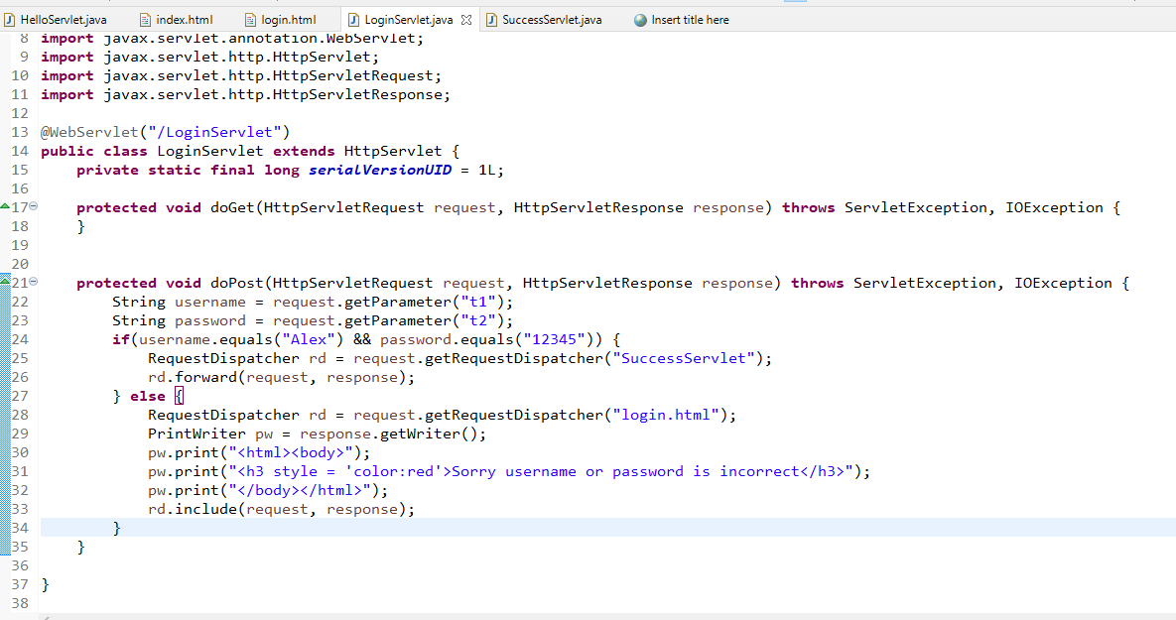

SuccessServlet

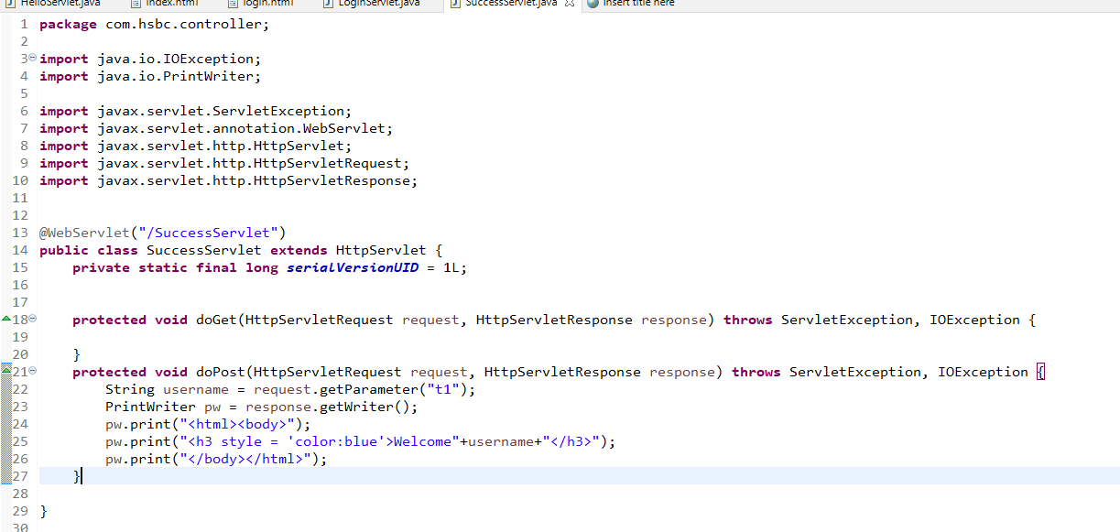

Output:

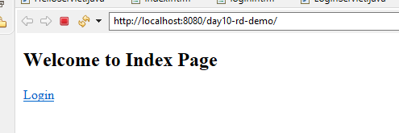

Output:

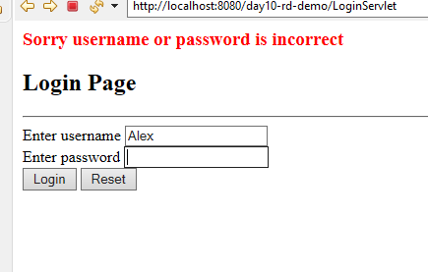

Interacting with the database using JDBC and layered architecture

1. Create dynamic web project
2. Convert to maven project
3. If maven project gives error saying web.xml is missing, generate web.xml using Deployment Description
4. Add mysql jar
5. Create a DBUtil to reuse connection for CRUD operations
6. Create Interface in DAO & Service, provide implementations
7. Create Factory pattern
8. Create servlets to handle request to perform store(), findAll() tasks
9. Create HTML to send form data

pom.xml

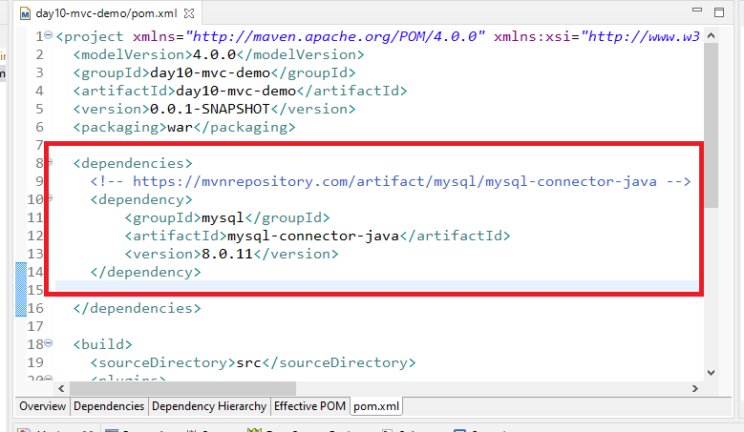

DBUtility.java

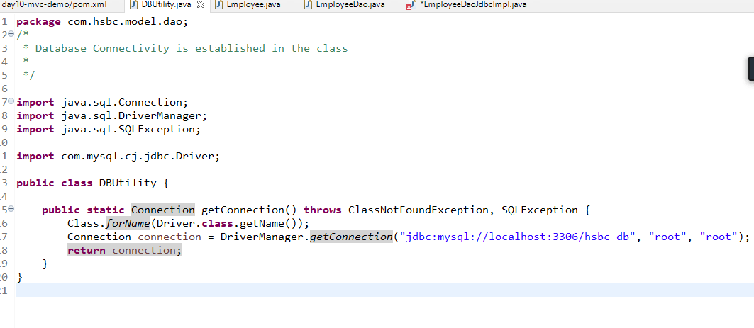

Employee.java

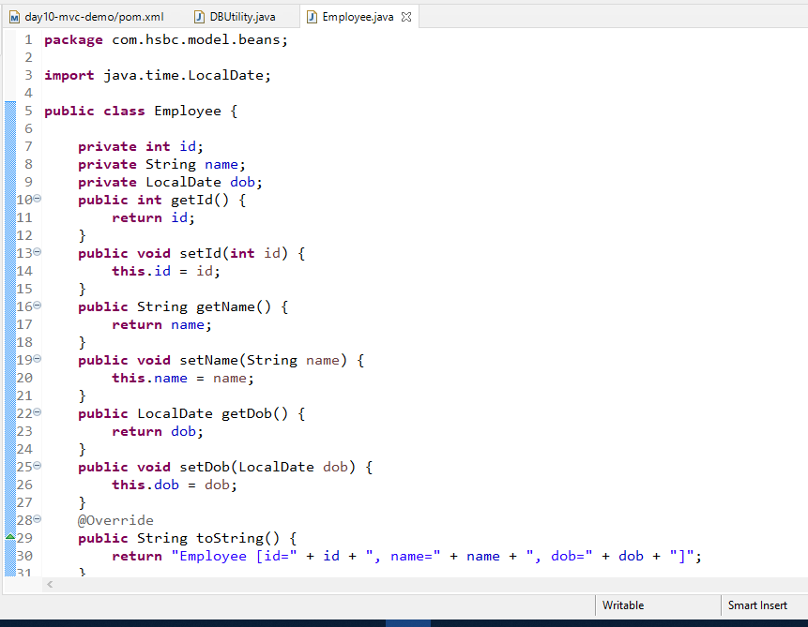

EmployeeDao.java

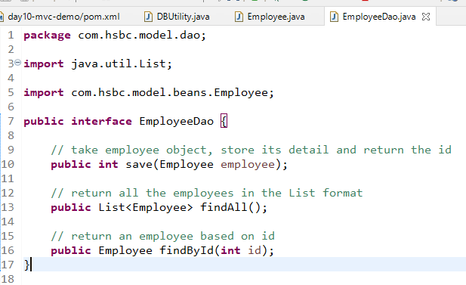

EmployeeDaoJdbcImpl.java

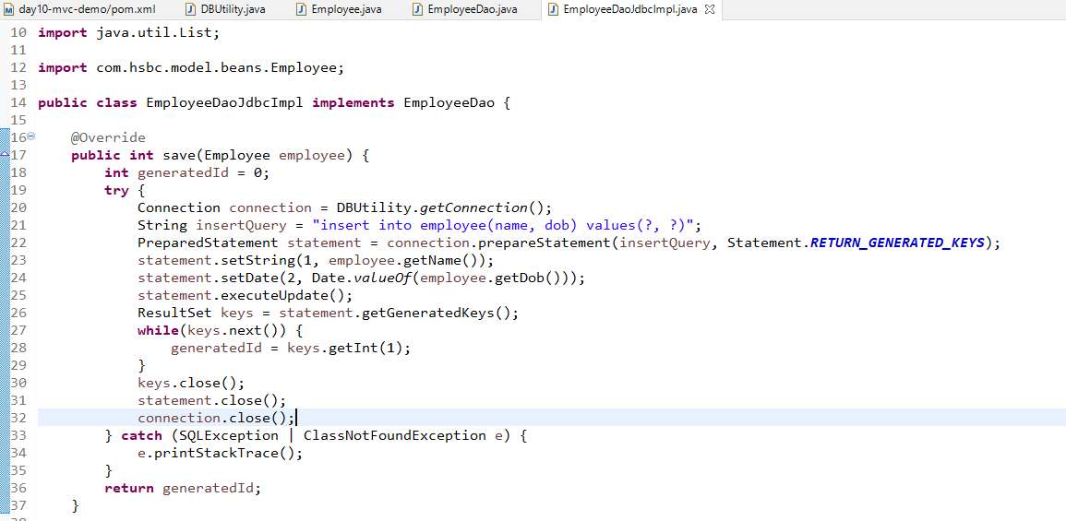

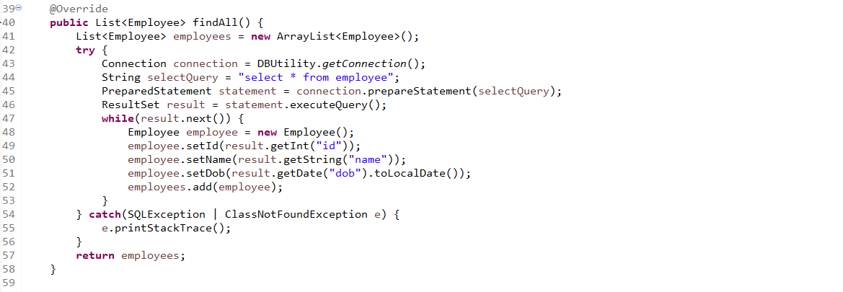

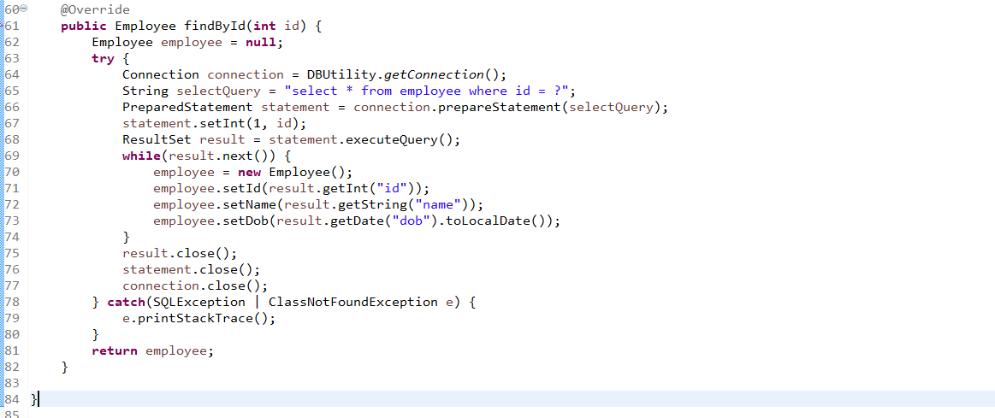

ObjectFactory.java

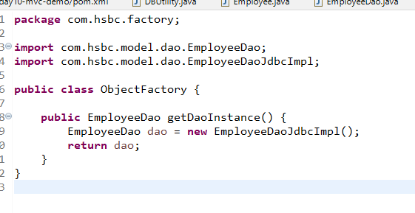

EmployeeService.java

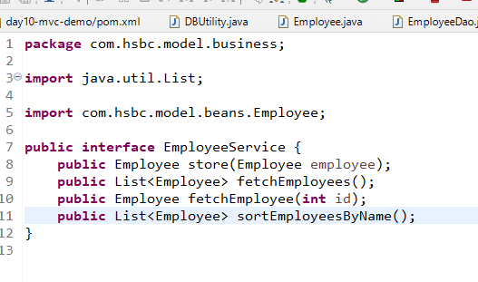

EmployeeServiceImpl.java

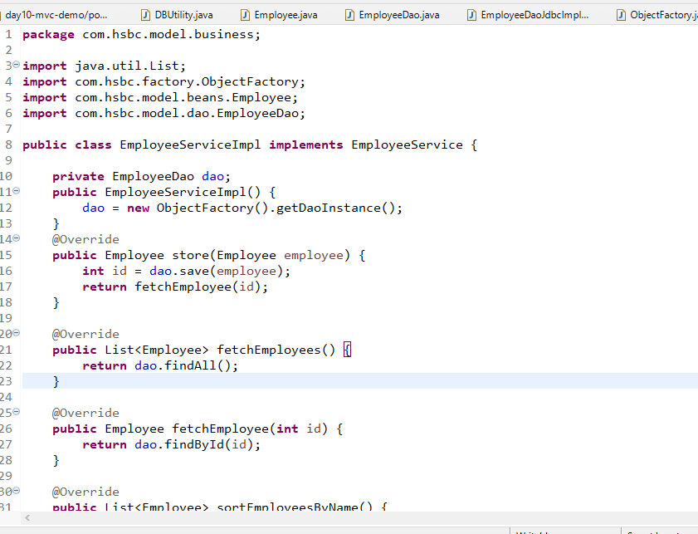

Modify the factory to return Service

ObjectFactory.java

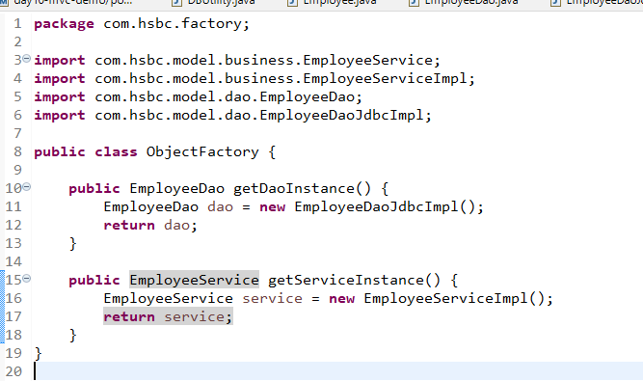

EmployeeStoreServlet.java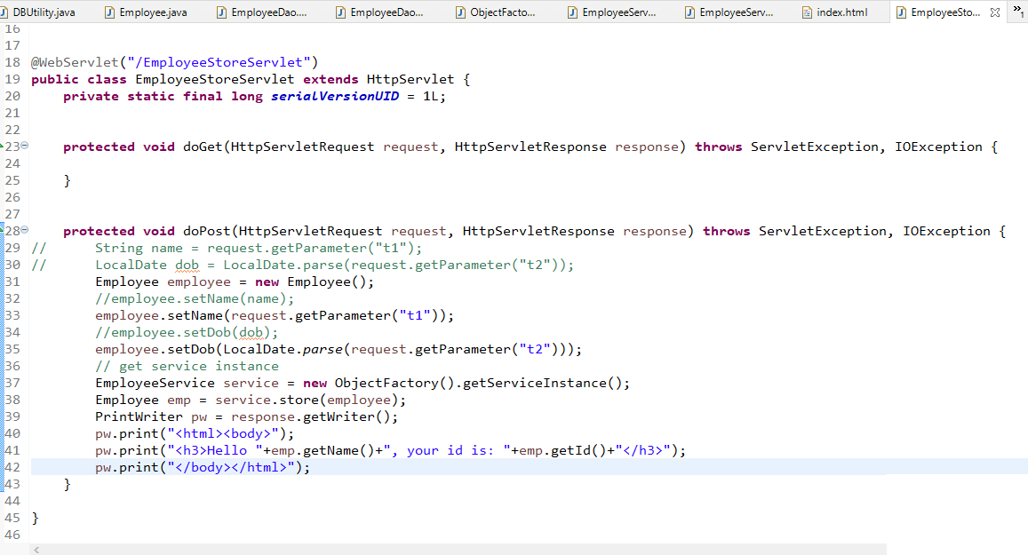

index.html

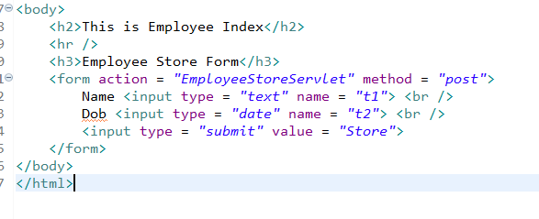

Output:

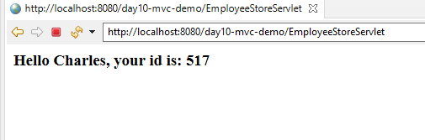

Exercise:

1. Display all the employees in a page
2. Display the employee based on id
3. Display all the employees whose name is sorted

Search Employee by id and Find All Employees

index.html

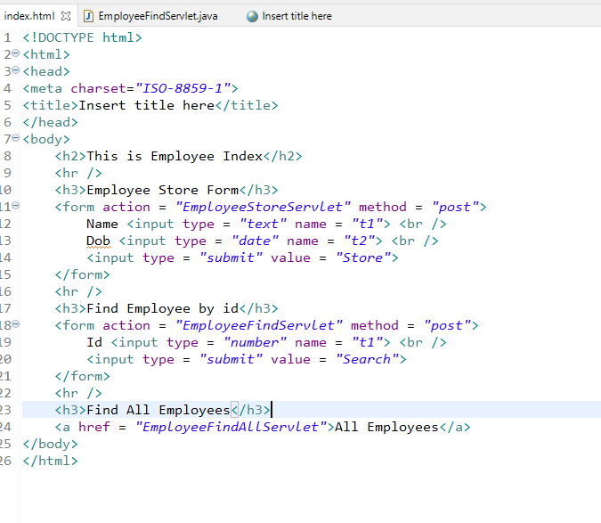

EmployeeFindServlet.java

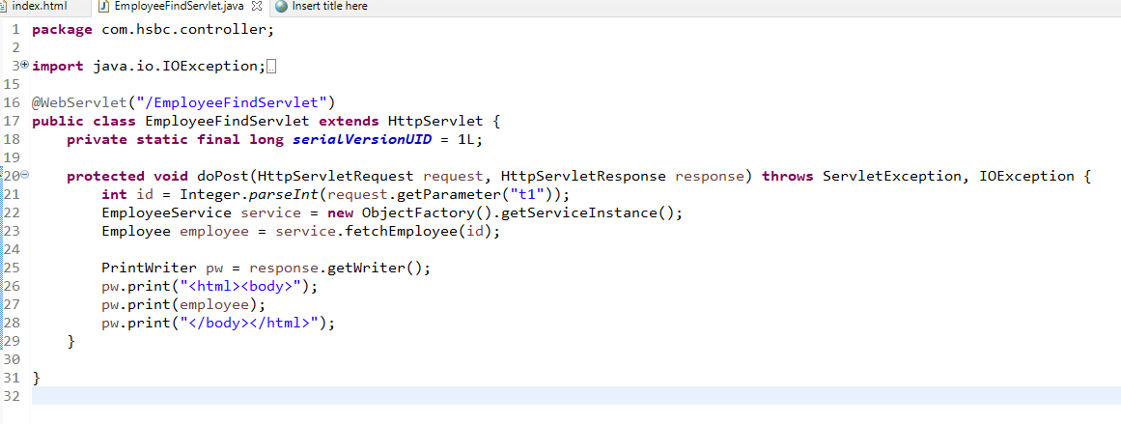

EmployeeFindAllServlet.java

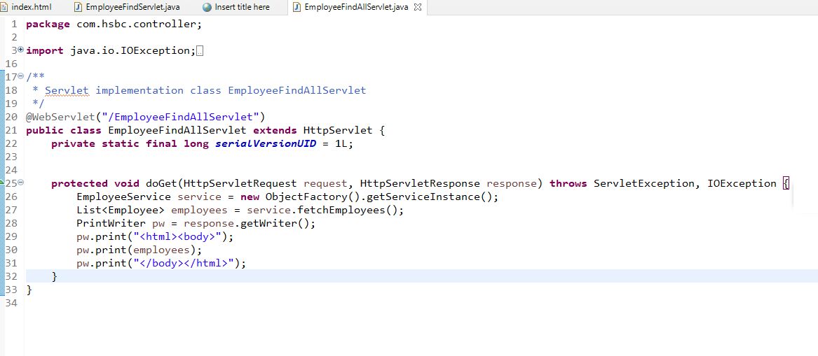

Output:



Converting Java objects to JSON

We need to use some third party library either gson, java-json and so on

pom.xml

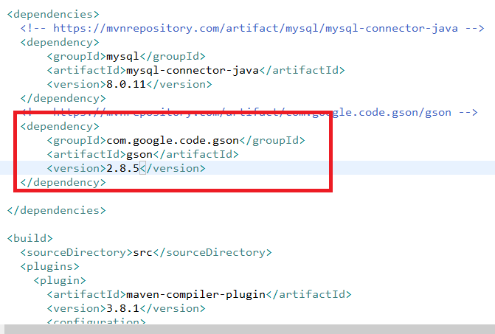

In GSON we have JsonConveter object to convert java objects to json

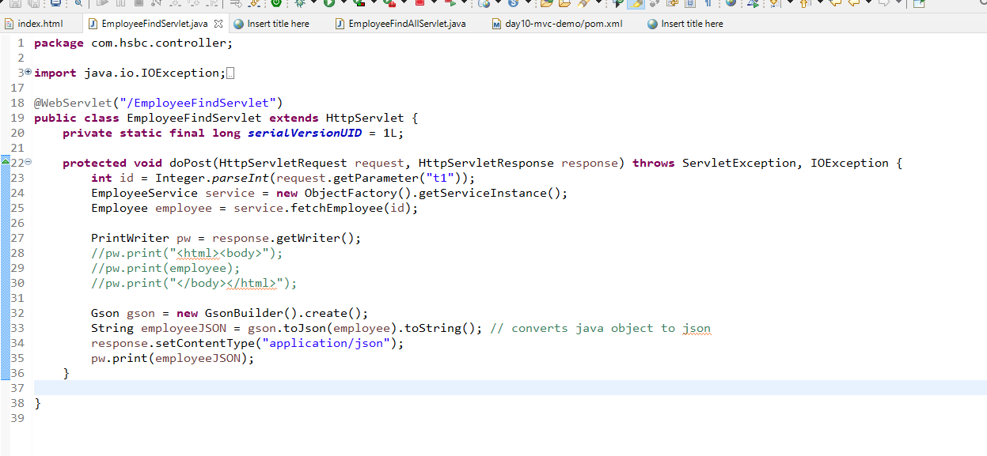

Output:

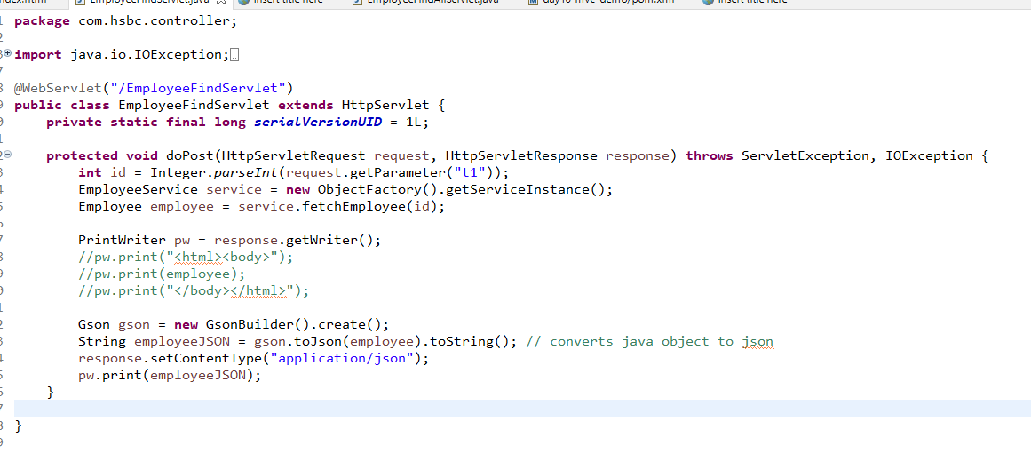

Exercise:

Convert the list of employees to JSON

How to consume this JSON in AJAX and display in a proper format

We need to create XmlHttpRequest and use open() and send() functions

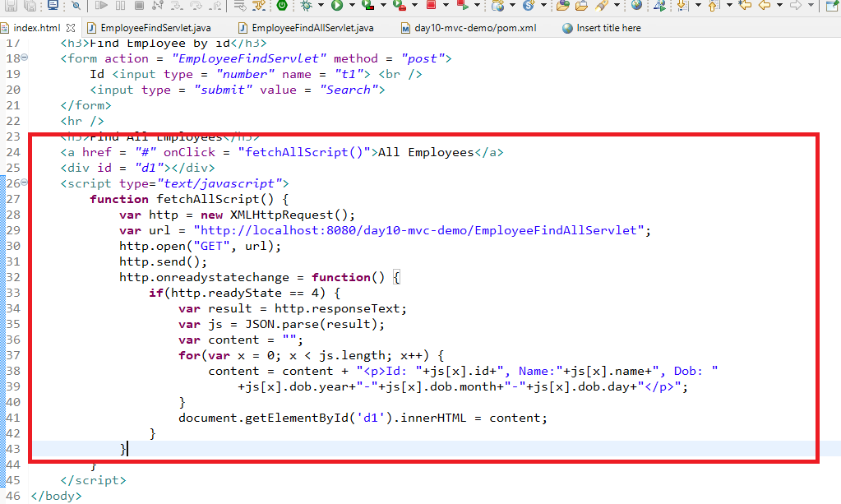

Output:

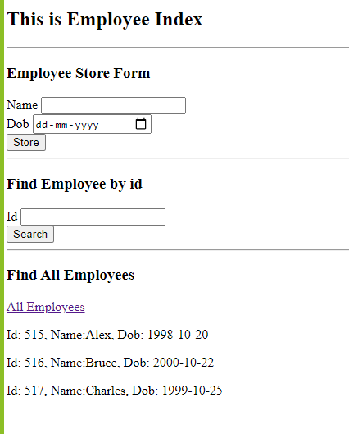

Making AJAX Call with post request

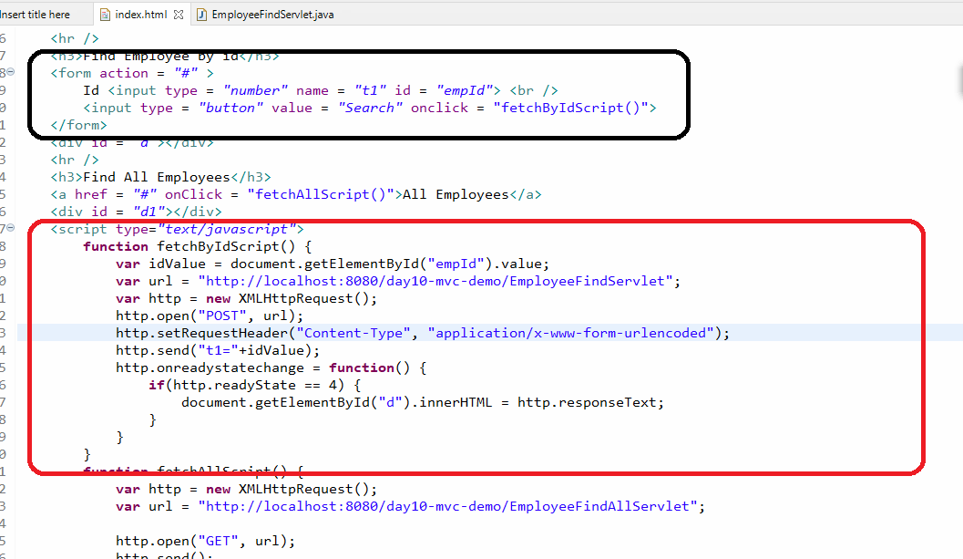

Output:

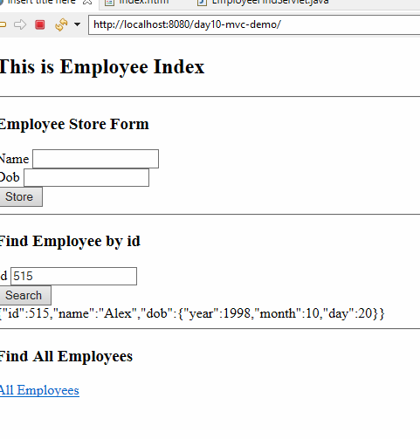

JSP: Java Server Pages

Note: JSP is not a replacement to the Servlet, it simplifies servlet responsibility by separating the presentation logic from servlet

It is used to develop dynamic web pages and it simplifies writing HTML code to present the dynamic data which was complex in Servlet.

JSP is written similar to HTML, it supports writing HTML code and Java code, but its advisable not to use Java code in JSP.

JSP plays View role according to MVC architecture, it is mainly for presentation purpose

How we write presentation logic in Servlet

Its very complex to develop dynamic content in servlet, for ex: assume you have a list of employees that needs to be rendered in the table then you will use servlet and html as below:

PrintWriter pw = response.getWriter();

pw.print(“<html><body>”);  
pw.print(“<table><tr><th>……</th>.....</tr>”);

for(Employee e : list) {  
 pw.print(“<tr style = ‘color:blue’>”+e.getId()+”<td>”+e.getName()+”</td></tr>”);  
}  
pw.print(“</table></body></html>”);

How we write presentation logic in JSP

<html><body>  
<table>  
 <tr><th>…</th>…</tr>  
 <tagForIterating value = “${list}” var = “e”>  
 <tr style = ‘color:blue’><td>${e.id}</td><td>${e.name}</td></tr>  
 </tagForIterating>  
</table>  
</body></html>

JSP building blocks

1. Directive elements
2. Scripting elements
3. Action elements
4. Implicit Objects

Directive Elements

They give instructions to the container/server, it has 3 types of elements

1. page directive: <%@page attributes %>
2. include directive: <%@include attributes %>
3. taglib directive: <%@taglib attributes %>

Scripting elements

It allows you to write java code there are three types of scripting elements

1. Declarative element: <%! declare some variables %>
2. Scriptlet element: <% some statements %>
3. Expression element: <%= print some expression %>

directiveDemo.jsp

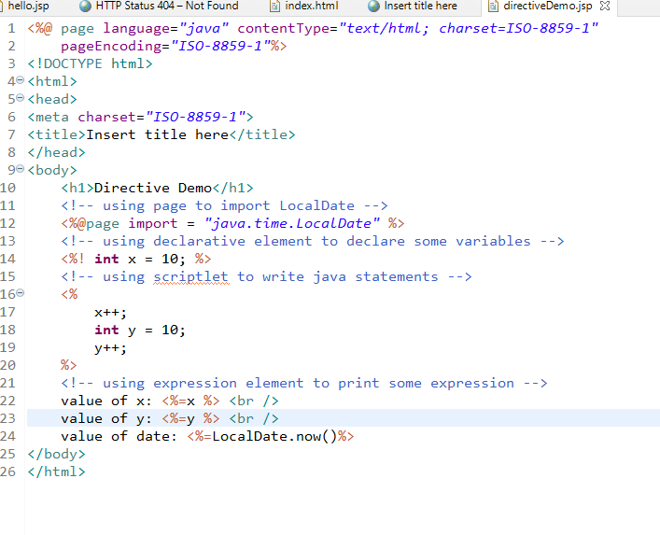

Every jsp file is converted to corresponding servlets, which is done by server only.

All your declarative elements goes inside the class

All the scriptlet code goes inside the converted jspService

All the expression goes inside the out.print() of jspService

include directive

It is mainly used to reuse the content of another file in the JSP

<%@include file = “file.extension”%>

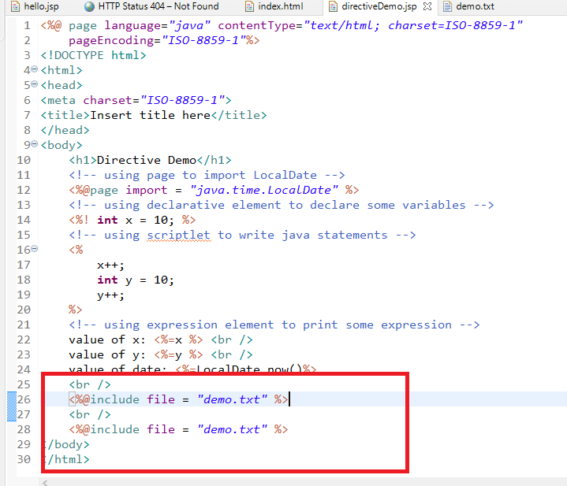

Here JSP only creating the data & displaying it, but in real-time data comes from DAO layer to Service layer to Controller to View layer

Since controller can specify the next page to be rendered it can also specify the jsp through RequestDispatcher

request -> servlet -> model -> request -> jsp

Earlier:

We sent request to the servlet and displaying the output through Servlets & HTML

Now:

We will send request to the servlet and display the output through JSP / HTML

index.html

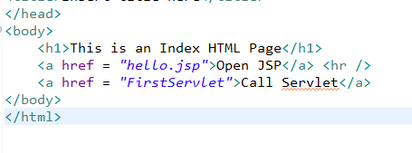

FirstServlet

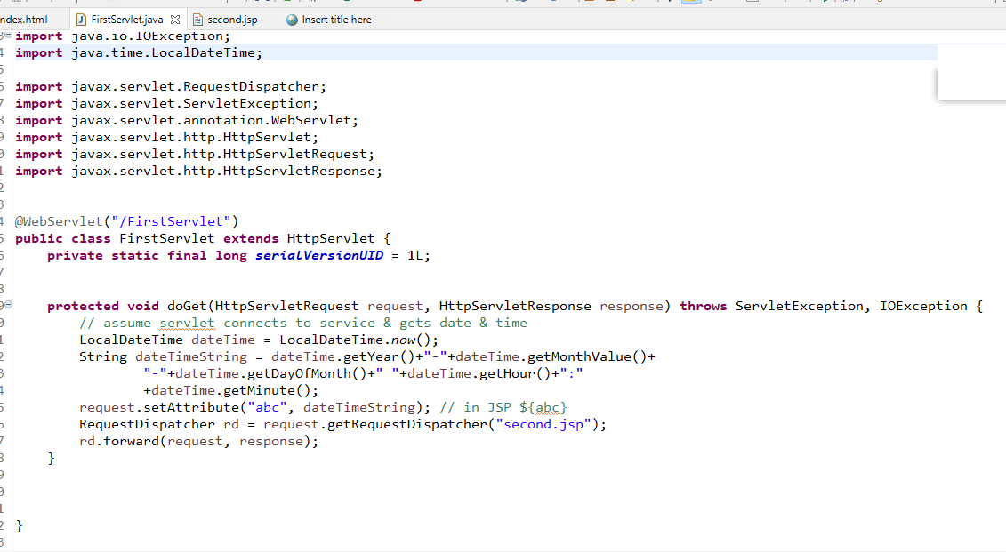

request.setAttribute(key, value): it is used to store the data in a request object so that the JSP can access it using the same key

Here key should be string & value can be of any type, it means you can store simple to complex type

second.jsp

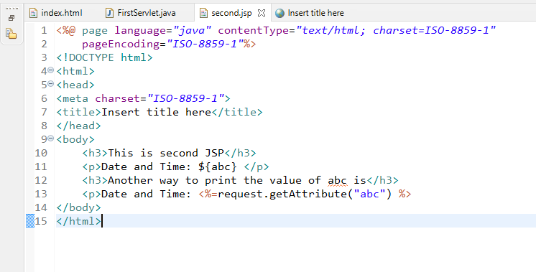

Output:

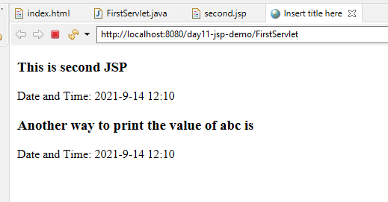

How to render complex data in the JSP

Employee.java

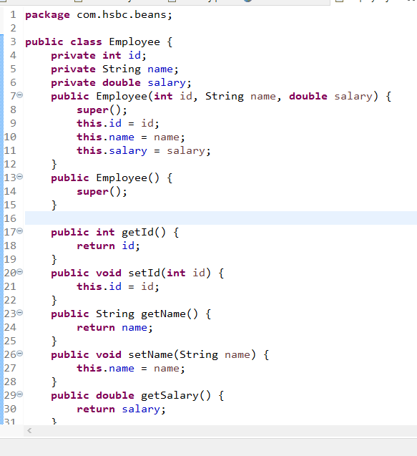

second.jsp

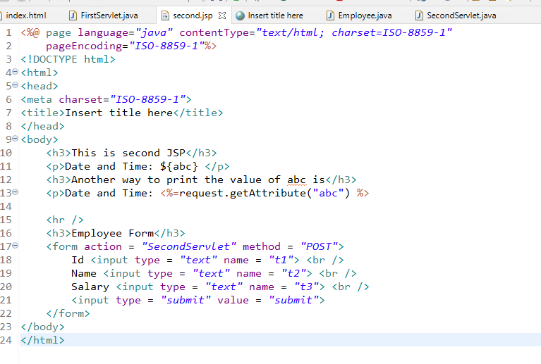

SecondServlet.java

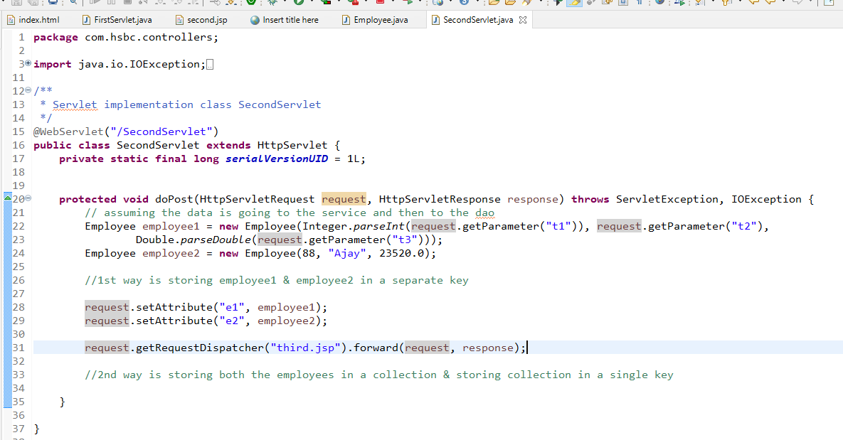

second.jsp

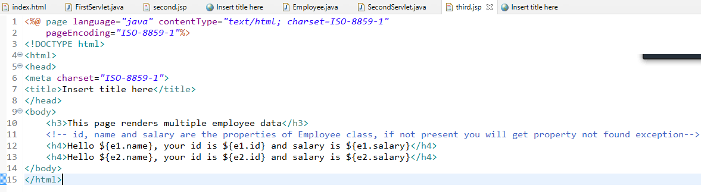

Output:

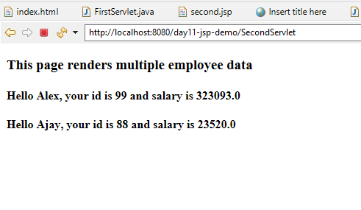

In Expression Language we can only access single object, we can’t have control statements like iteration or conditional blocks, which is required when you want to render the collection of data based on some conditions.

So solve this issue we need to go for JSTL stands for Java Standard Tag Library

JSTL provides some tags using which you can write control statements, iteration statements, variable declaration, formatting and so on.

JSTL is not provided by default, it should be used by adding jstl.jar file

Convert the dynamic web project to maven project so that you can add jstl.jar

pom.xml

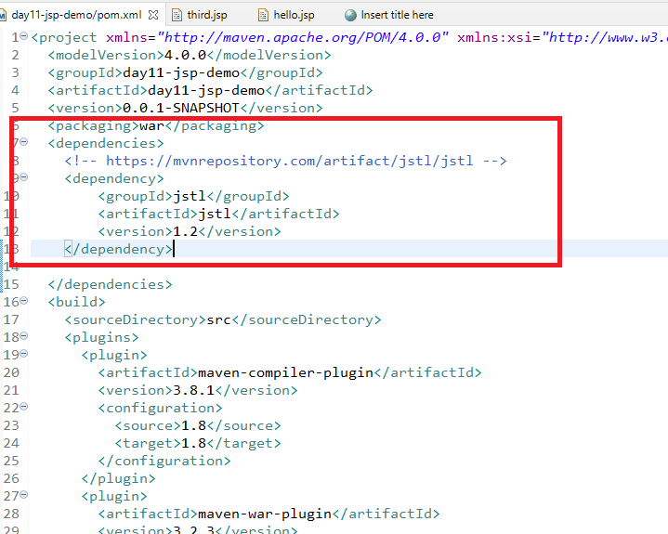

hello.jsp

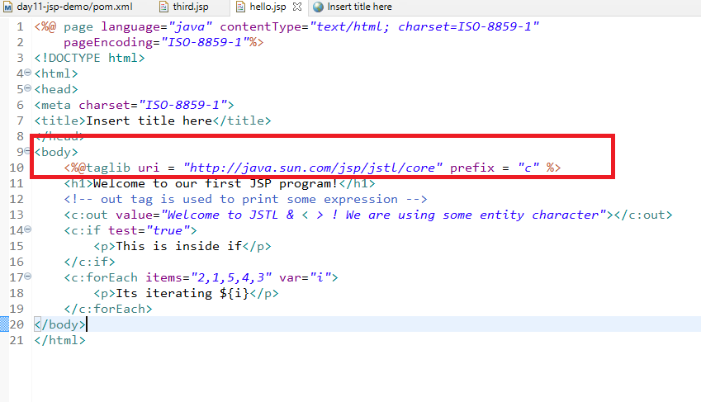

Now we can access these data from the servlet and render it ex: List<Employee> can be iterated using forEach

third.jsp

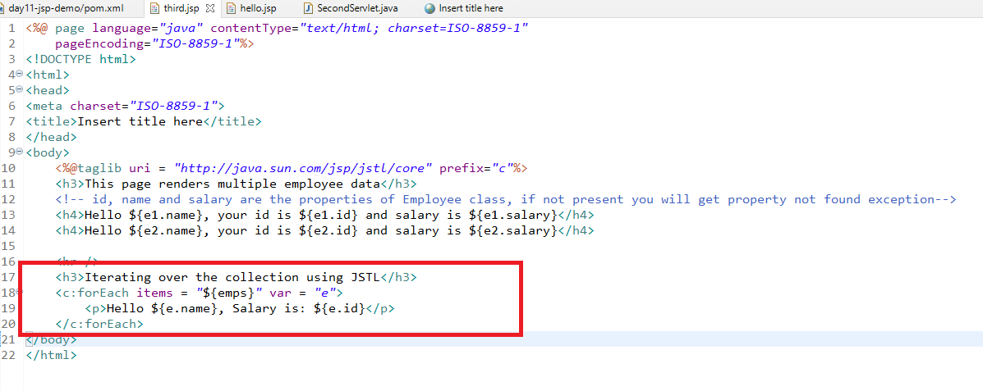

When you are sharing the data from servlets to JSP you can share in 3 different ways

1. request : HttpServletRequest - per page
2. session: HttpSession - per session or per user
3. context/application: ServletContext - for multiple sessions

request is limited only to the next page, it can’t be accessed in the subsequent request or on the new request

session is available for multiple request within the session, session is per user/browser

In all the 3 ways you store the data using same method setAttribute(key, value)

How to use request

request objects is already available in every servlet through doGet() or doPost() parameters

request.setAttribute(key, value)

How to use session

session object is created with request object

HttpSession session = request.getSession(); // it is created per user, it is created if session is not available, if available it will use the existing session

session.setAttribute(key, value)

How to use context or application scope data i.e., ServletContext

ServletContext ctx = getServletContext(); // getServletContext() is present in HttpServlet so you can directly call without using any reference

ctx.setAttribute(key, value)

SecondServlet.java

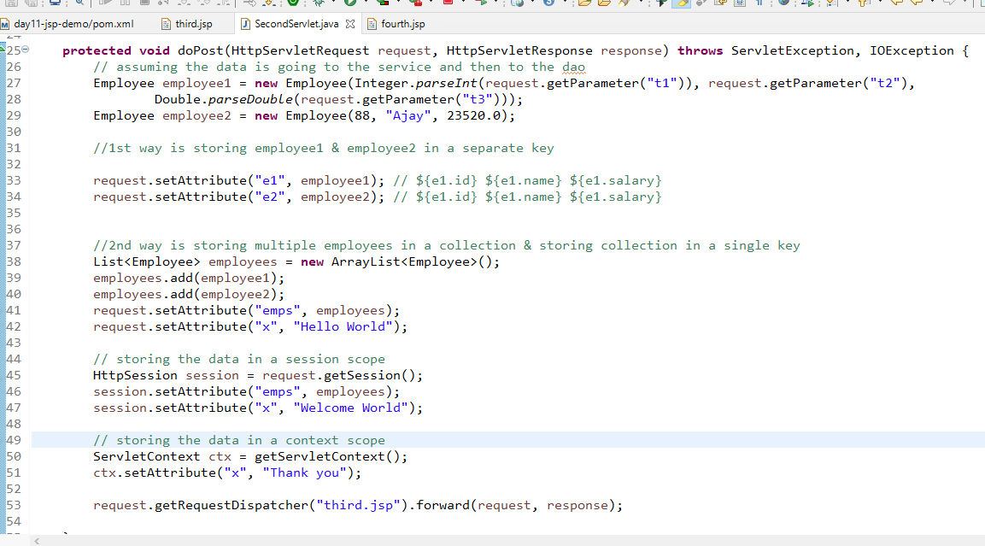

third.jsp

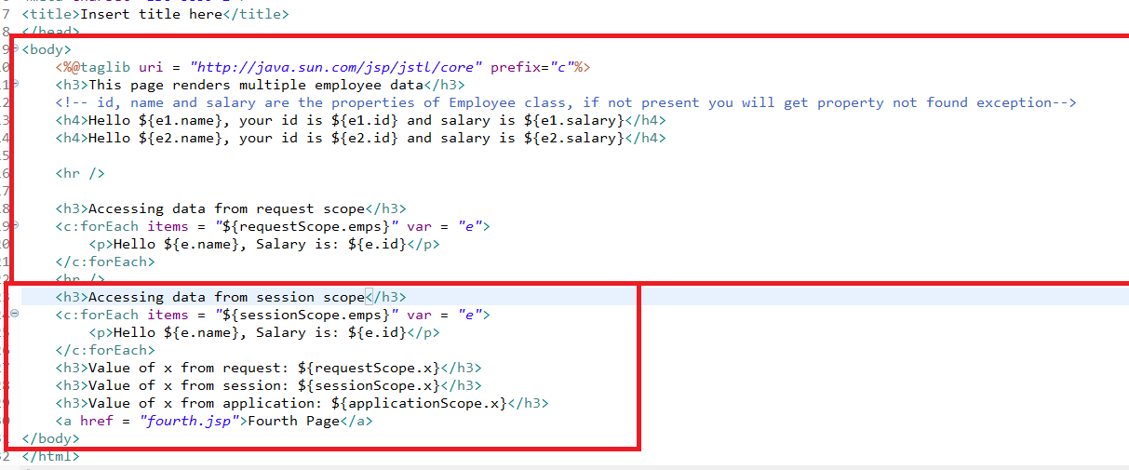

fourth.jsp

